Azure Monitoring Workshop

Proctor’s Guide

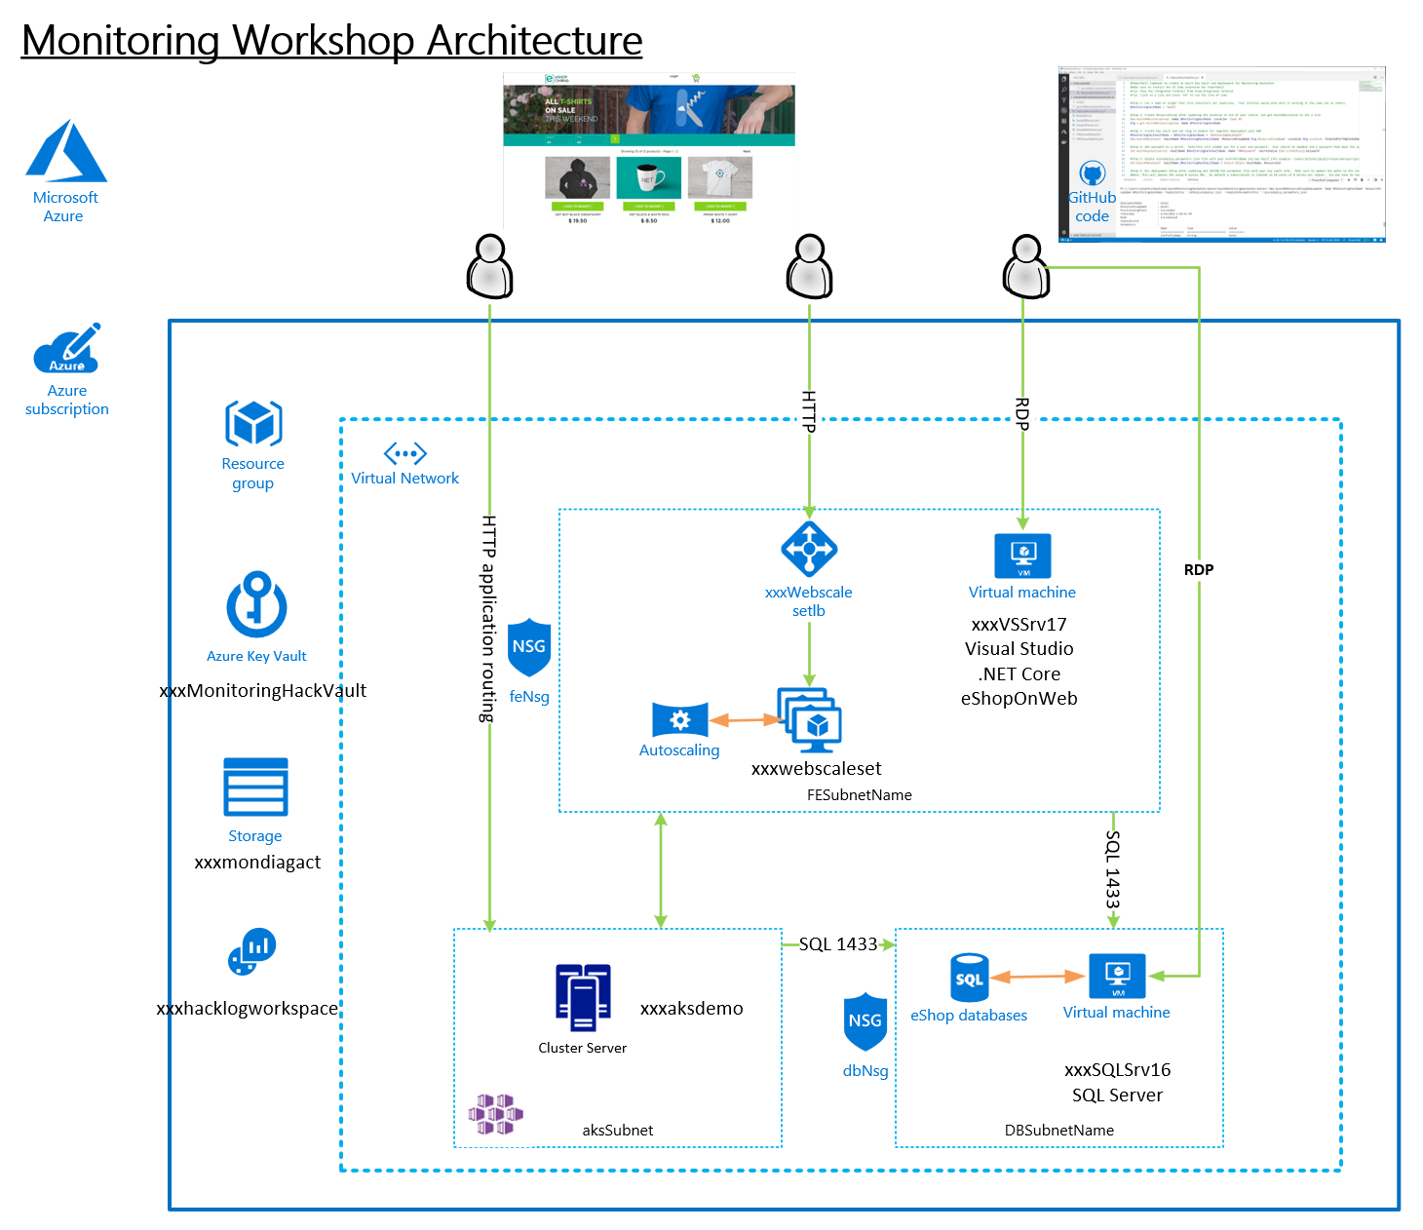

Version 1.1

Contents

Workshop Setup 3

Guidance 3

Challenge 1: Monitoring and Alert Rule 3

Challenge 2: Monitoring and Alert Rule Automation 25

Challenge 3: Application Insights 32

Challenge 4: Azure Monitor for Containers 46

Challenge 5: Log Analytics Query 56

Challenge 6: Dashboard and Analytics 60

Challenge 6a: Workbooks 82

# Workshop Setup

* Deploy Infra using Bash Cloud Shell and Azure CLI with an ARM Template
  + Setup Azure CLI  
    <https://docs.microsoft.com/en-us/cli/azure/install-azure-cli?view=azure-cli-latest>
  + Install Visual Studio Code and Extensions (depending on your tool of choice)
    - Azure Resource Manager Tools - <https://marketplace.visualstudio.com/items?itemName=msazurermtools.azurerm-vscode-tools>
    - Azure Account and Sign-In (adds the Azure Cloud Shell for Bash) - <https://marketplace.visualstudio.com/items?itemName=ms-vscode.azure-account>  
      Azure CLI Tools –   
      <https://marketplace.visualstudio.com/items?itemName=ms-vscode.azurecli>
  + Download Azure Monitoring Workshop Setup Guide and follow the instructions to deploy.  
    <https://github.com/rkuehfus/pre-ready-2019-H1/blob/master/Student/Guides/Deployment%20Setup%20Guide.docx?raw=true>

## Guidance

Biggest issues I have seen when deploying the workshop are around compute quotas, changing the region to one that does not support the Azure Monitor preview, not having contributor role membership to the subscription and local machine issues. If you run into a student who cannot seem to get her or his computer working with the Azure CLI, have them use the Azure Cloud Shell. Remember to copy up the ARM template and parameters JSON files before kicking off the deployment.

I highly recommend your students make sure they have an Azure Subscription they have contributor role access to before day one of the hack.

# Challenge 1: Monitoring and Alert Rule

* Create an empty database called “tpcc” on the SQL Server  
  Note: Use SQL Auth with the username being sqladmin and password being whatever you used during deployment
  + Connect (RDP) to the Visual Studio Server (xxxxxVSSrv17) using its public IP address and open Visual Studio. Create an account if you don’t have one.
  + VS has view called SQL Server Object Explorer that can be used to create and delete SQL databases on the SQL server  
    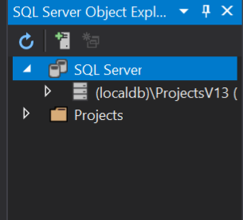
  + Connect to the database server VM, make sure to use sqladmin and the password you stored in the key vault during deployment  
    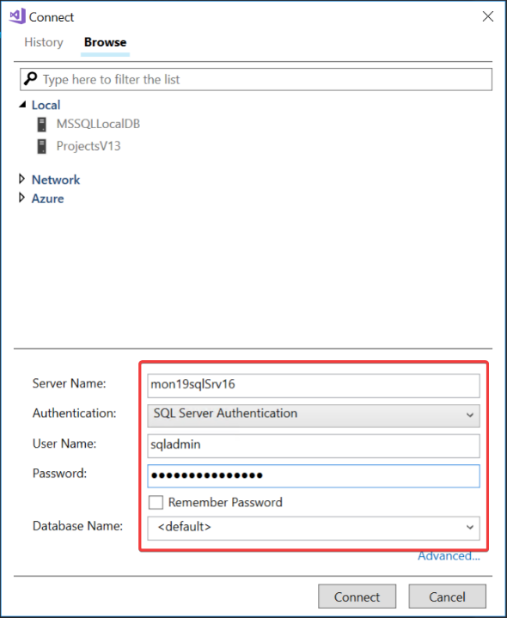  
    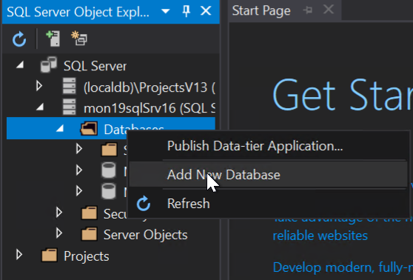  
    Once connected create a new database called “tpcc”

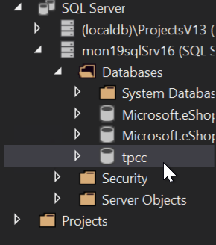

* From the ARM template, send the below guest OS metric to Azure Monitor for the SQL Server
  + Add a Performance Counter Metric for
    - Object: SQLServer:Databases
    - Counter: Active Transactions
    - Instance:tpcc
  + Hint: <https://docs.microsoft.com/en-us/azure/monitoring-and-diagnostics/metrics-store-custom-guestos-resource-manager-vm>
  + First, figure out the correct format for the counter use the run command on the SQL Server in the Azure portal and run –

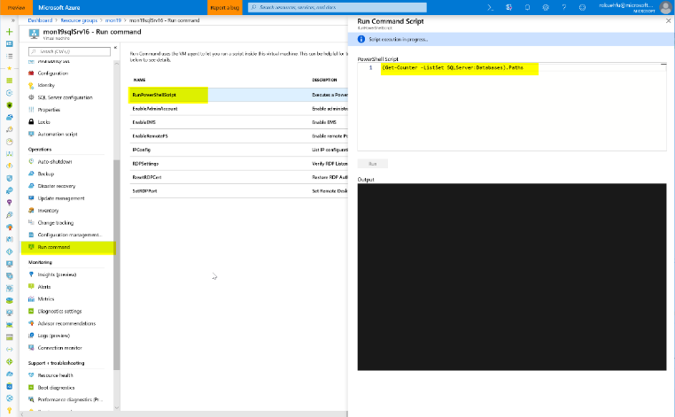

Run the command - (Get-Counter -ListSet SQLServer:Databases).Paths

Once its finished, review the results (scroll up) and copy the output for the SQLServer:Databases counter.  
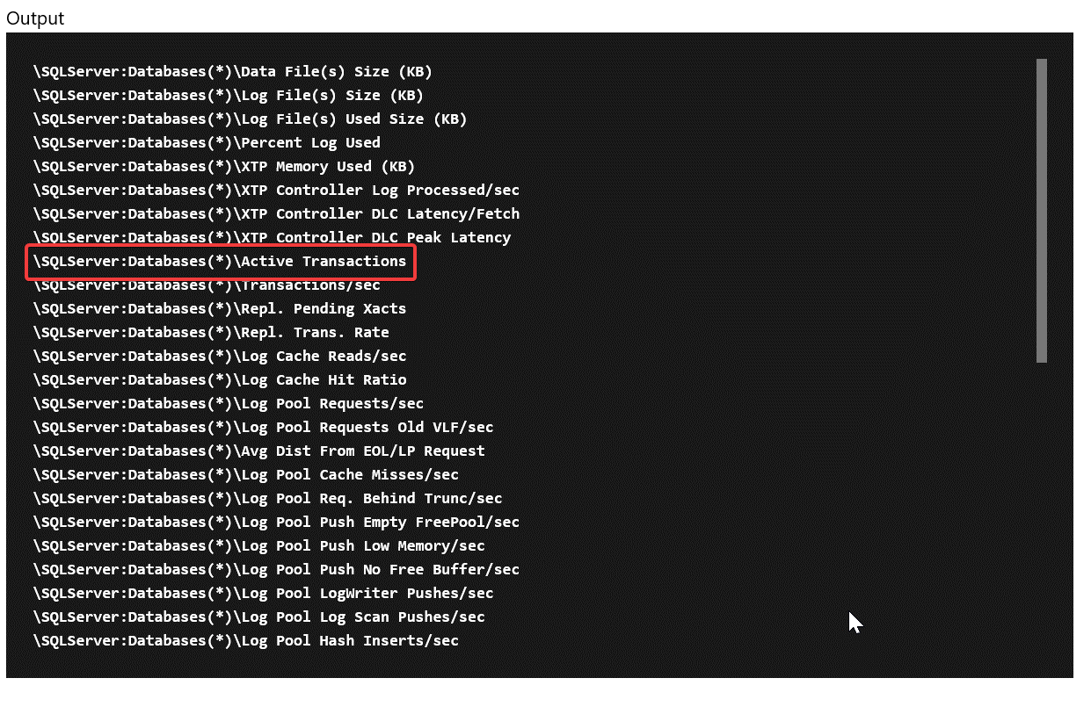

\SQLServer:Databases(*)\Active Transactions

Then change it to target just your specific database

\SQLServer:Databases(tpcc)\Active Transactions

**Tip:** Share the following link to help lead them to how to find the counter

<https://docs.microsoft.com/en-us/powershell/module/microsoft.powershell.diagnostics/get-counter?view=powershell-5.1>

Next, once you have the counter you need to modify the ARM template for the SQL Server to add the collection of this counter that sends it to Azure Monitor using the Azure monitor data sink

Add this JSON to the SQL Server code

Verify the identity is present in the template (add it if its missing)

"identity": {

"type": "SystemAssigned"

},

And the missing counter below

"resources":[

{

"type": "extensions",

"name": "Microsoft.Insights.VMDiagnosticsSettings",

"apiVersion": "2015-05-01-preview",

"location": "[resourceGroup().location]",

"dependsOn": [

"[concat('Microsoft.Compute/virtualMachines/', concat(parameters('envPrefixName'), 'sqlSrv16'))]"

],

"properties": {

"publisher": "Microsoft.Azure.Diagnostics",

"type": "IaaSDiagnostics",

"typeHandlerVersion": "1.5",

"autoUpgradeMinorVersion": true,

"settings": {

"WadCfg": {

"DiagnosticMonitorConfiguration": {

"overallQuotaInMB": 4096,

"DiagnosticInfrastructureLogs": {

"scheduledTransferLogLevelFilter": "Error"

},

"Directories": {

"scheduledTransferPeriod": "PT1M",

"IISLogs": {

"containerName": "wad-iis-logfiles"

},

"FailedRequestLogs": {

"containerName": "wad-failedrequestlogs"

}

},

"PerformanceCounters": {

"scheduledTransferPeriod": "PT1M",

"sinks": "AzMonSink",

"PerformanceCounterConfiguration": [

{

"counterSpecifier": "\\Memory\\Available Bytes",

"sampleRate": "PT15S"

},

{

"counterSpecifier": "\\Memory\\% Committed Bytes In Use",

"sampleRate": "PT15S"

},

{

"counterSpecifier": "\\Memory\\Committed Bytes",

"sampleRate": "PT15S"

},

{

"counterSpecifier": "\\SQLServer:Databases(tpcc)\\Active Transactions",

"sampleRate": "PT15S"

}

]

},

"WindowsEventLog": {

"scheduledTransferPeriod": "PT1M",

"DataSource": [

{

"name": "Application!*"

}

]

},

"Logs": {

"scheduledTransferPeriod": "PT1M",

"scheduledTransferLogLevelFilter": "Error"

}

},

"SinksConfig": {

"Sink": [

{

"name": "AzMonSink",

"AzureMonitor": {}

}

]

}

},

"StorageAccount": "[variables('storageAccountName')]"

},

"protectedSettings": {

"storageAccountName": "[variables('storageAccountName')]",

"storageAccountKey": "[listKeys(variables('accountid'),'2015-06-15').key1]",

"storageAccountEndPoint": "https://core.windows.net/"

}

}

},

{

"type": "extensions",

"name": "WADExtensionSetup",

"apiVersion": "2015-05-01-preview",

"location": "[resourceGroup().location]",

"dependsOn": [

"[concat('Microsoft.Compute/virtualMachines/', concat(parameters('envPrefixName'), 'sqlSrv16'))]"

],

"properties": {

"publisher": "Microsoft.ManagedIdentity",

"type": "ManagedIdentityExtensionForWindows",

"typeHandlerVersion": "1.0",

"autoUpgradeMinorVersion": true,

"settings": {

"port": 50342

}

}

}

]

Save and redeploy.

Once redeployed, go to metrics and check to make sure you are seeing the new metrics.   
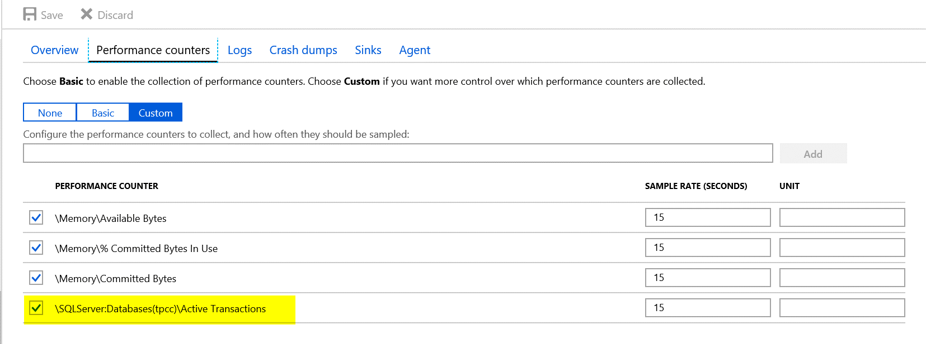

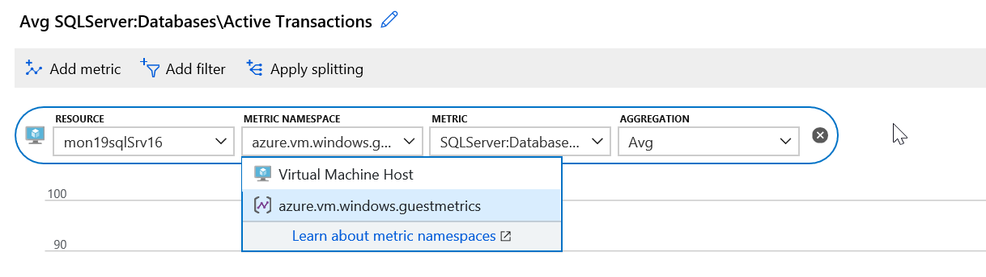

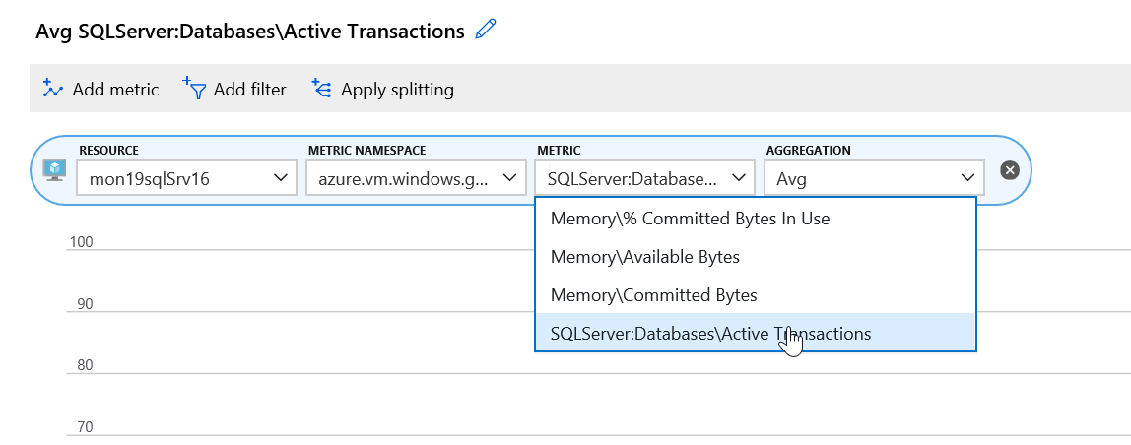

**Tip:** A bunch of OS metrics are configured already under the scale set as a sample.

* Download and Install HammerDB tool on the Visual Studio VM. Note: I copy of these instructions are in the student folder under “AzureMonitoringHackathon\Student\Guides\Day-1”
  + [www.hammerdb.com](http://www.hammerdb.com/)

**Note:** HammerDB does not have native support for Windows Display Scaling. This may result in a smaller than usual UI that is difficult to read over high resolution RDP sessions. If you run into this issue later, close and re-open your RDP session to the VSServer with a lower display resolution. After the RDP session connects, you can zoom into to adjust the size.

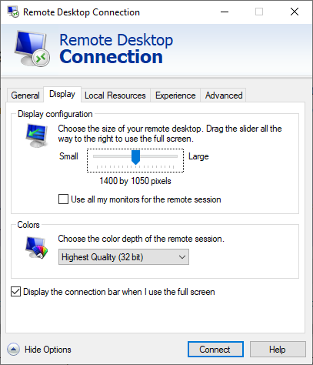 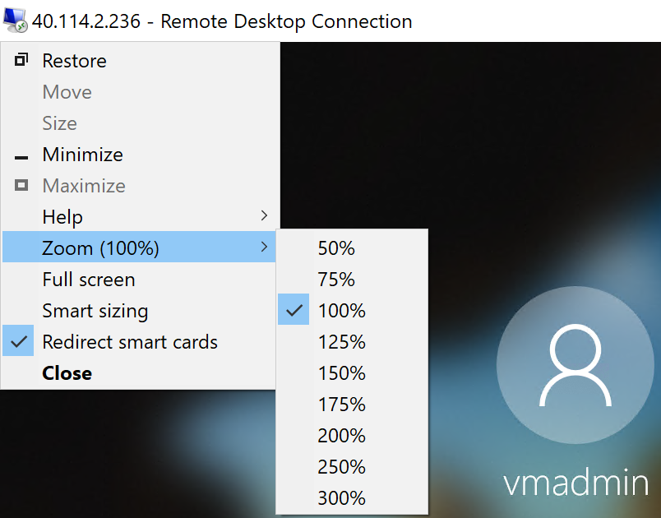

From the Visual Studio Server, download the latest version of HammerDB  
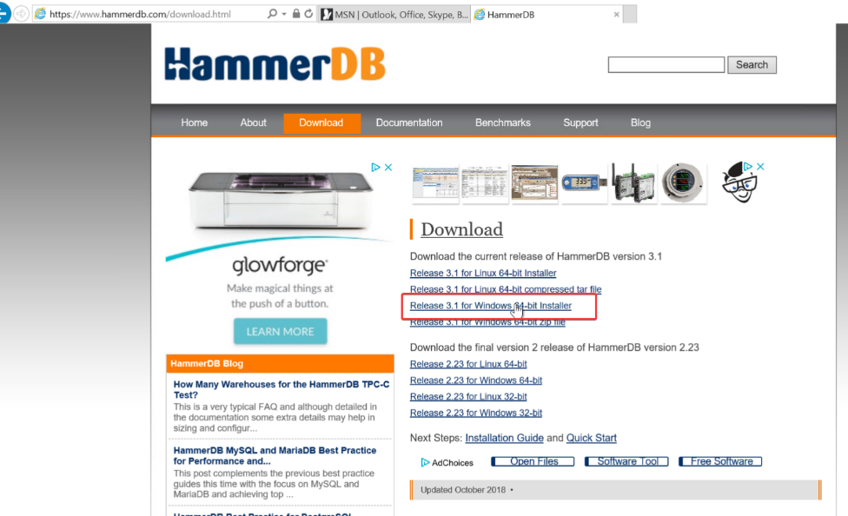

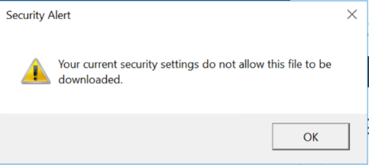

If you get this Security Warning, go to Internet Options.

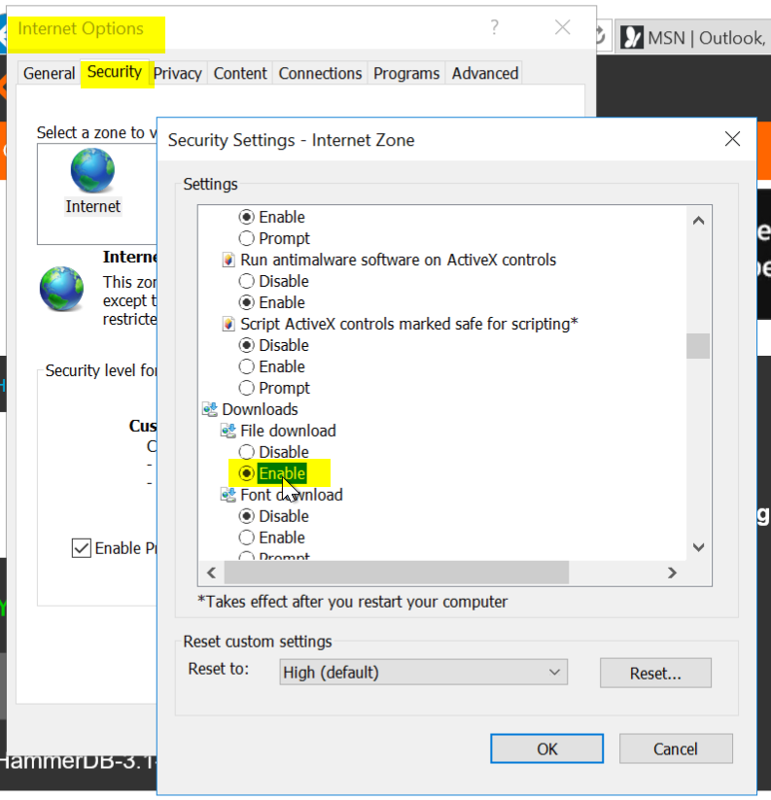

Security \ Security Settings \ Downloads \ File download \ Enable

Click OK

Try again



Click Actions and accept the warnings

Tip: If you end up closing HammerDB you have to go to C:\Program Files\HammerDB-3.1 and run the batch file

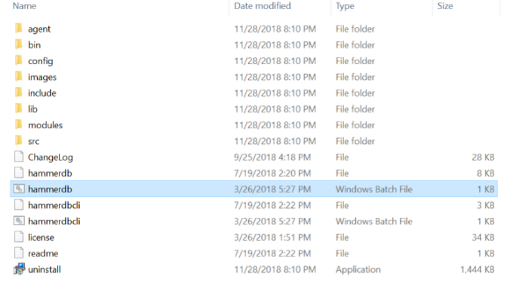

* Use HammerDB to create transaction load

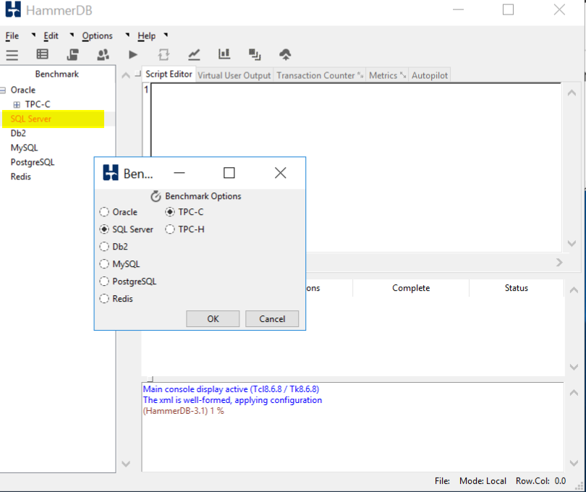

Double click on SQL Server and click OK, and OK on the confirm popup

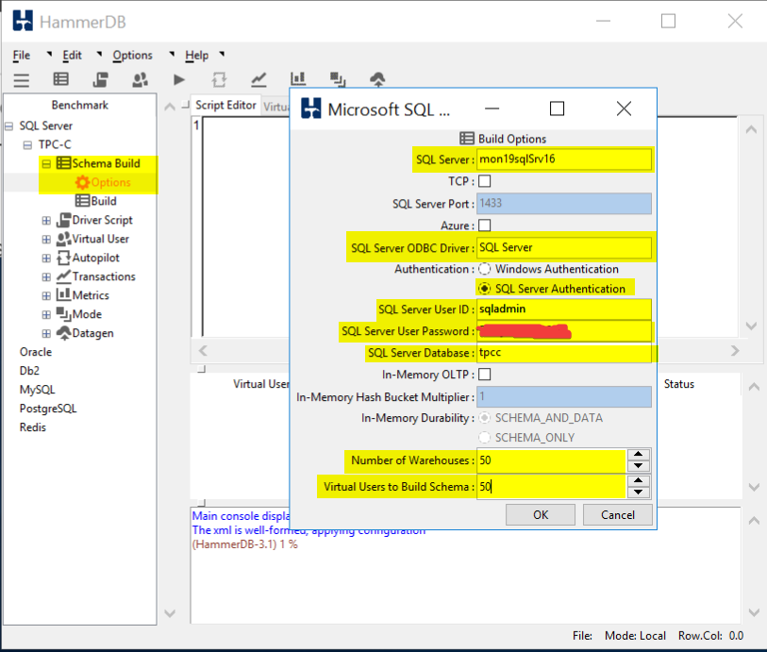

Drill into SQL Server \ TPC-C \ Schema Build and double click on Options

Modify the Build Options for the following:

SQL Server: Name of your SQL Server

SQL Server ODBC Driver: SQL Server

Authentication: SQL Server Authentication

SQL Server User ID: sqladmin

SQL Server User Password: <password you stored in the Key Vault>

SQL Server Database: tpcc

Number of Warehouses: 50

Virtual Users to Build Schema: 50

Note: Setting the last two at 50 should generate enough load to trip a threshold and run long enough for you to graph

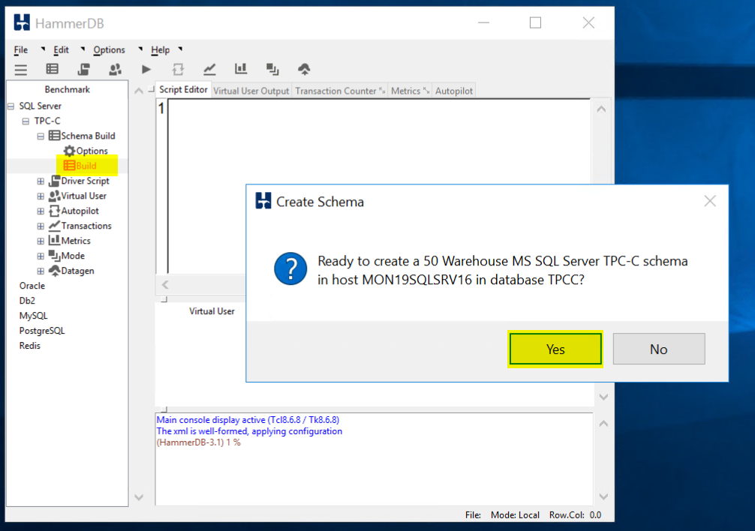

Double click on Build and Click Yes to kick of a load test.

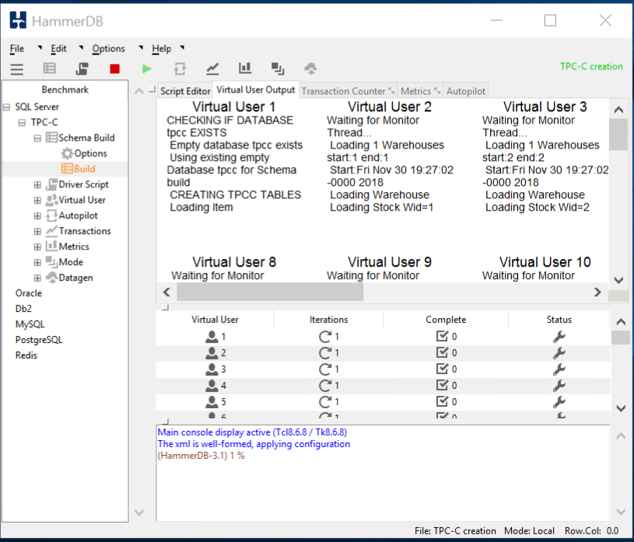

When the test is running it should like this.

TIP: If you would like to run a second test you **must** first delete the database you created and recreate it. HammerDB will not run a test against a database that has data in it. When you run a test is fills the database with a bunch of sample data.

* From Azure Monitor,
  + Create a graph for the SQL Server Active Transactions and Percent CPU and pin to your Azure Dashboard
  + Note: I had to customize the dashboard once I pinned it to a new Azure Dashboard  
    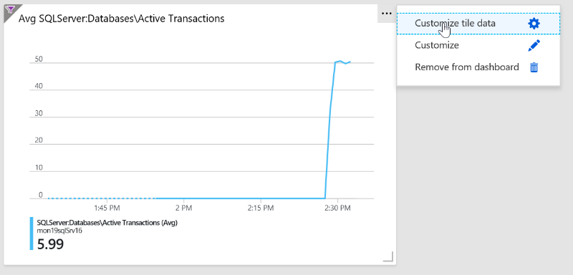

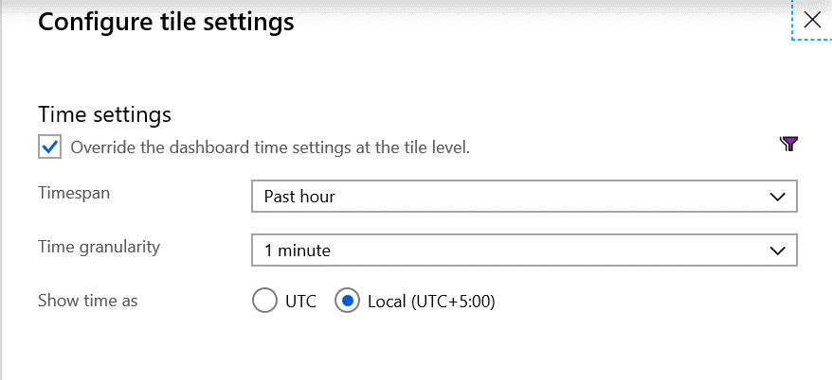  
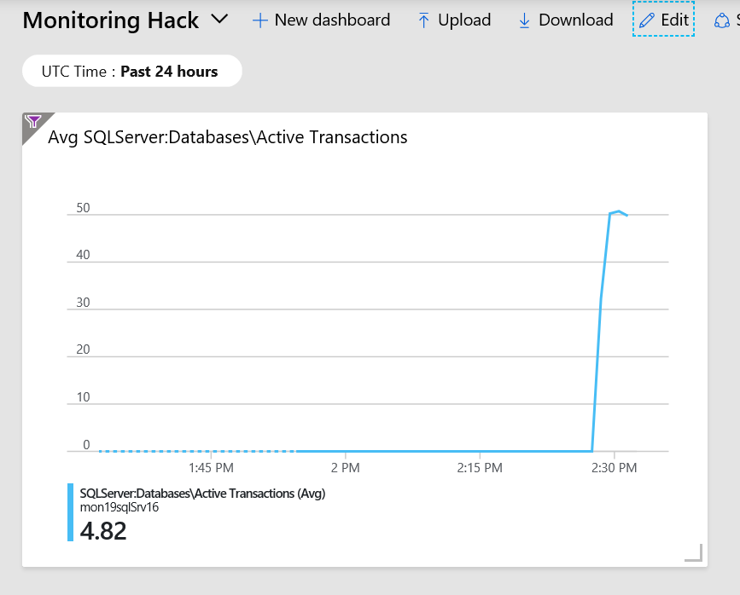

Dashboard should look something like this.

* + From Azure Monitor, create an Action group, to send email to your address

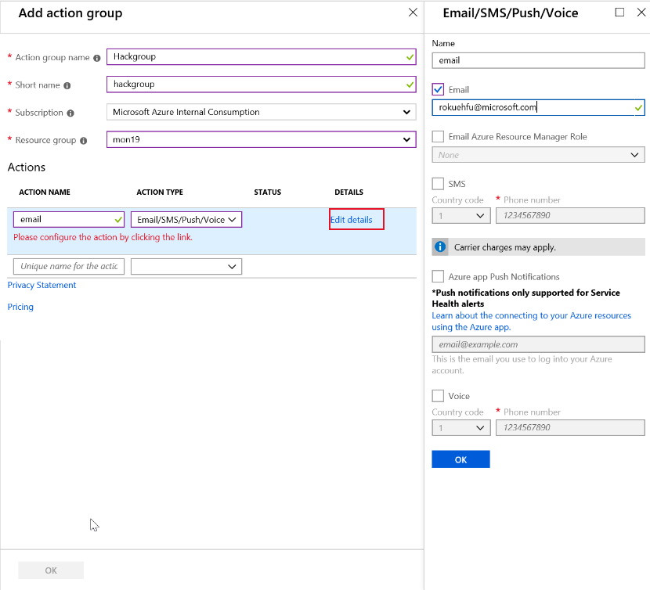

* + Create an Alert if Active Transactions goes over 40 on the SQL Server tpcc database.

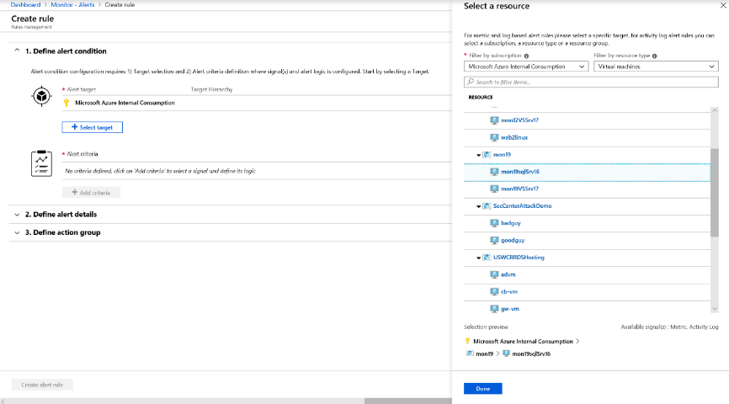

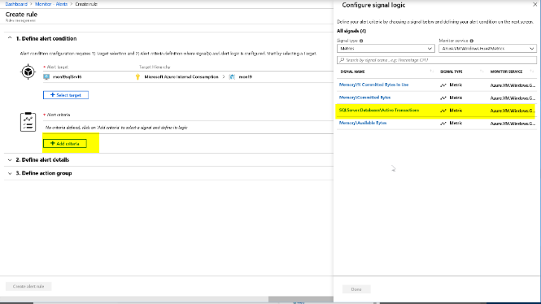

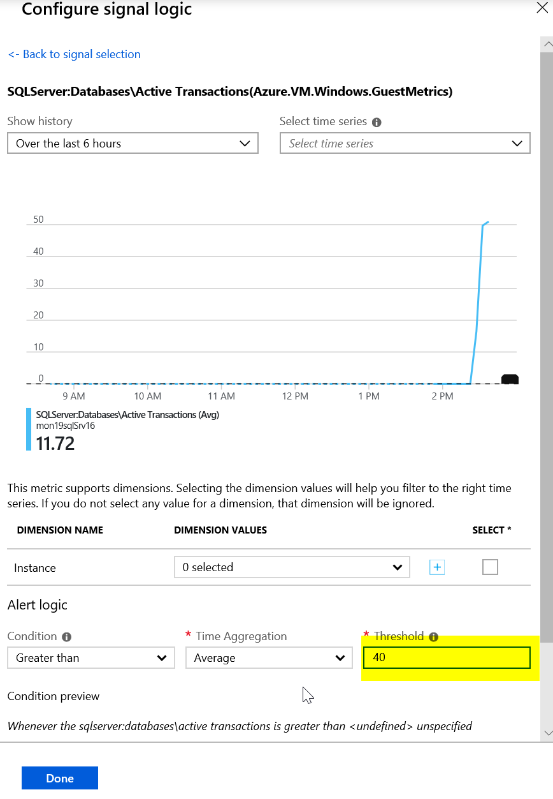

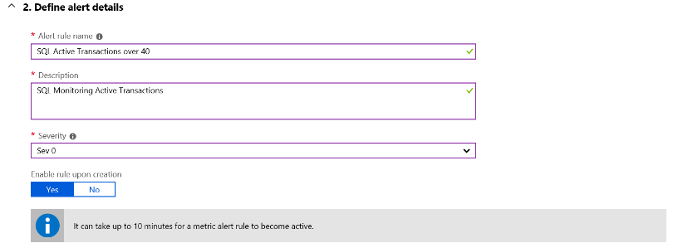

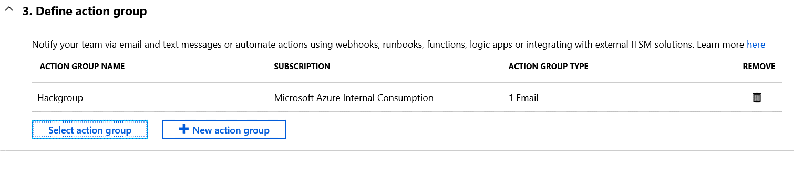



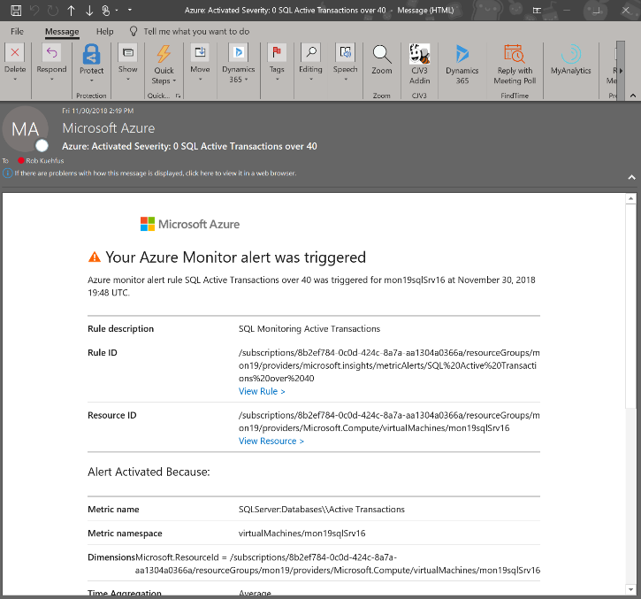

* Create an Alert Rule for CPU over 75% on the Virtual Scale Set that emails me when you go over the threshold.

First create a dashboard to watch the Scale Set CPU

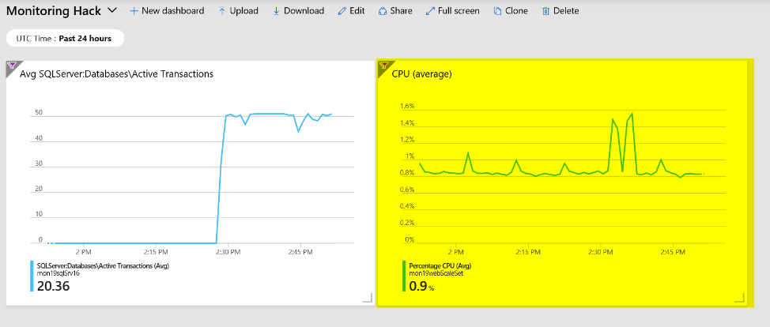

Navigate to the folder called “Loadscripts” under the Resources folder in Student and copy the cpuGenLoadwithPS.ps1 script to both instances running in the Scale Set and run them.

This may be a bit of a challenge to those not used to working with a scale set. If your student just grabs the public IP address and then RDP to it. They will end up on one of the instances but because they are going through the Load Balancer, they cannot control which one. Or can they? 😊

If you look at the configuration of the LB it is configured with an inbound NAT rule that will map starting at port 50000 to each instance in the Scale Set. So if they RDP using the PIP:50000 for instance 1 and PIP:50001 for instance 2.

"inboundNatPools": [

{

"name": "natpool",

"properties": {

"frontendIPConfiguration": {

"id": "[concat(variables('webLbId'), '/frontendIPConfigurations/loadBalancerFrontEnd')]"

},

"protocol": "Tcp",

"frontendPortRangeStart": 50000,

"frontendPortRangeEnd": 50119,

"backendPort": 3389

}

}

],

For Example,

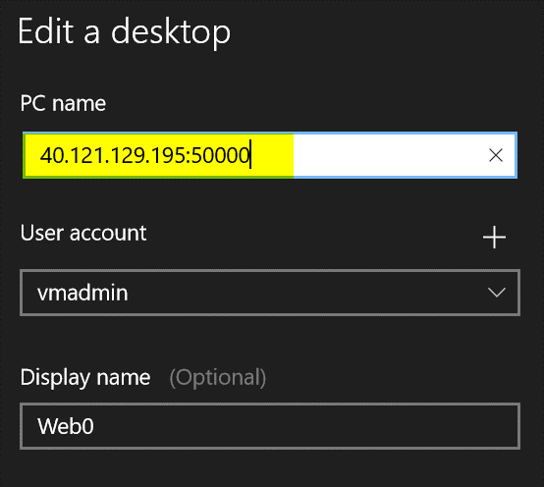

Jump on to both VMs in the Scale Set, Open the PowerShell ISE, Copy the script in the window and run it. You may need to run it more then once to really add the pressure. This script will pin each core on the VM no matter how many you have.

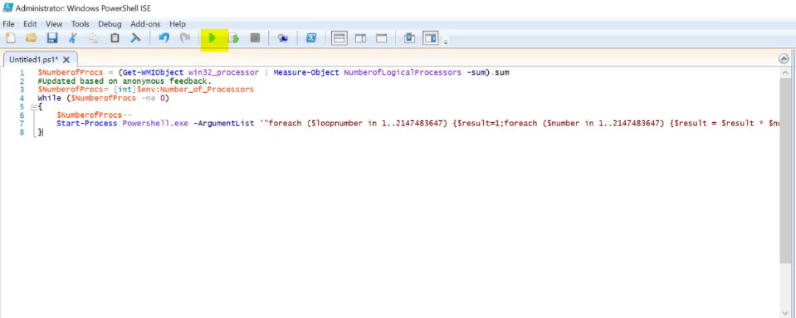

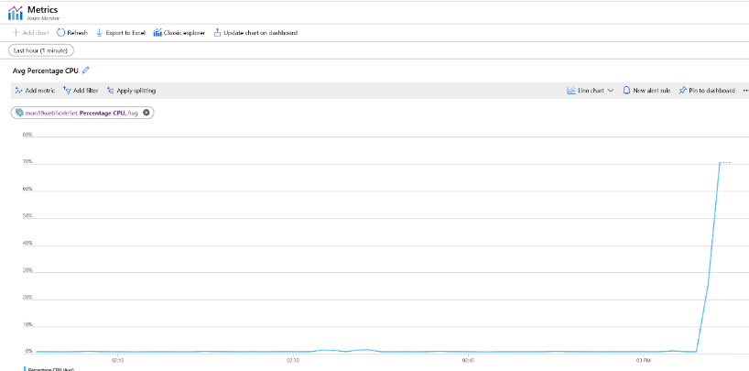

The trick to getting the alert to fire is to pin both instances at the same time as the CPU metric is an aggregate of the scale set. If you just max the CPU on one server to 100% the Scale Set is only at 50% and till not trip the alert threshold of 75%. Also, if they run the script and then setup the Alert Rule then to back to run another test to trip the alert, they have scaled out to a third instance and not realized it. They may need to jump on that box and max it out as well.

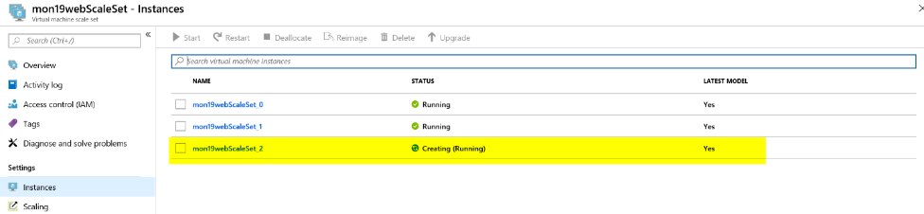

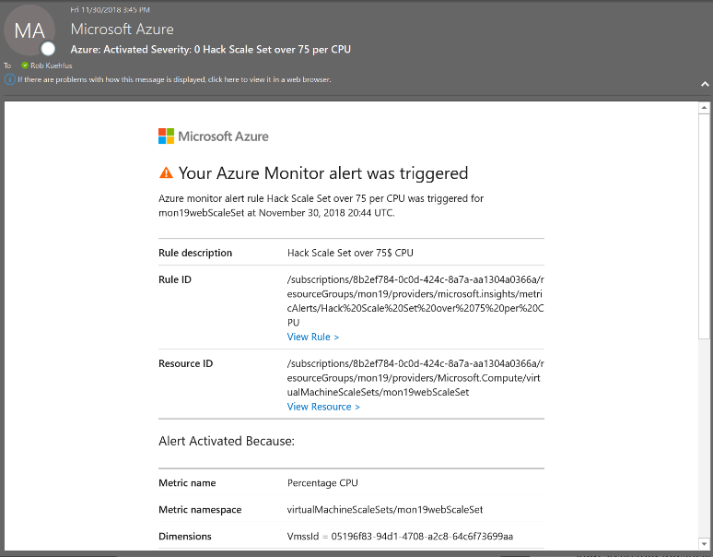

* First team to send me both alerts wins the challenge!!
* Good luck!

# Challenge 2: Monitoring and Alert Rule Automation

* Update the parameters file and deployment script for the GenerateAlertRules.json template located in the AlertTemplates folder
  + Add the names of your VMs and ResouceId for your Action Group

To find the ResourceId for your Action group navigate to the Resource Group where you are stored the action group and make sure to check off “Show hidden types”.

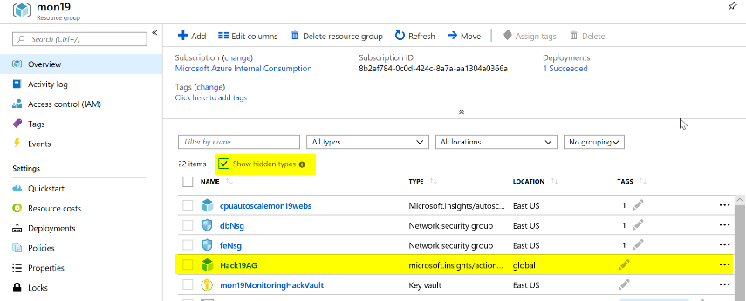

Click on your Action Group and copy the ResourceId

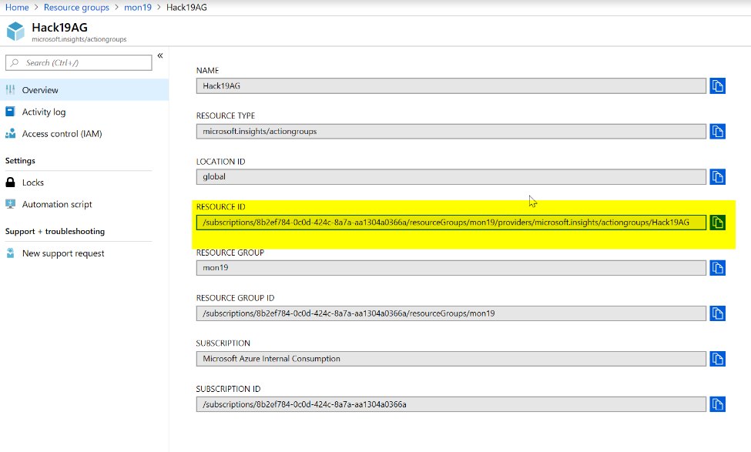

Then update the deployAlertRules.parameters.json file as it shows below.

Or

In the deployAlertRulesTemplates.ps1 script update the resourcegroup and run the first few lines then run the code to get the Azure Monitor Action Group

#Get Azure Monitor Action Group

(Get-AzActionGroup -ResourceGroup "Default-activityLogAlerts").Id

Copy and paste the resource Id for the Action Group you would like to use.

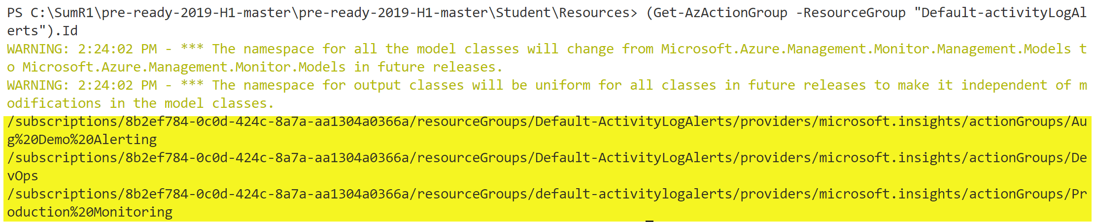

Save the parameters file and update the deployAlertRulesTemplate.ps1 file with the name of your Resource Group (and save it).

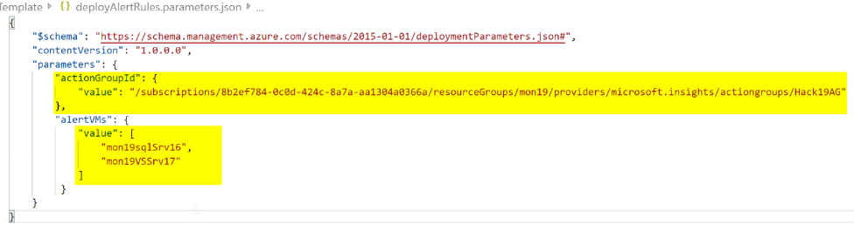

* Deploy the GenerateAlertRules.json template using the sample PowerShell script (deployAlertRulesTemplate.ps1) or create a Bash script (look at the example from the initial deployment)

#Update Path to files as needed

#Update the parameters file with the names of your VMs and the ResourceId of your Action Group (use command above to find ResourceId)

$template=".\AlertsTemplate\GenerateAlertRules.json"

$para=".\AlertsTemplate\deployAlertRules.parameters.json"

$job = 'job.' + ((Get-Date).ToUniversalTime()).tostring("MMddyy.HHmm")

New-AzureRmResourceGroupDeployment `

-Name $job `

-ResourceGroupName $rg.ResourceGroupName `

-TemplateFile $template `

-TemplateParameterFile $para

* Verify you have new Monitor Alert Rules in the Portal or from the command line (sample command is in the deployment script)

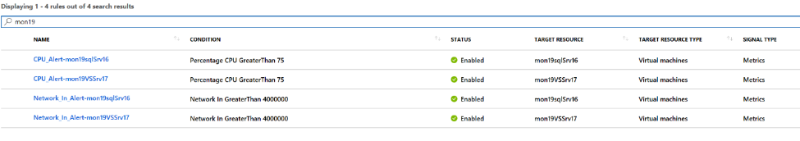

* Modify the GenerateAlertsRules.json to include “Disk Write Operations/Sec” and set a threshold of 10  
  **Tip:** Go here to view the list of metrics available by resource type - <https://docs.microsoft.com/en-us/azure/monitoring-and-diagnostics/monitoring-supported-metrics#microsoftcomputevirtualmachines>

Use this link to see the ARM schema - <https://docs.microsoft.com/en-us/rest/api/monitor/metricalerts/update>

{

"type": "Microsoft.Insights/metricAlerts",

"name": "[concat('Disk_Write_Alert','-',parameters('alertVMs')[copyIndex()])]",

"copy": {

"name": "iterator",

"count": "[length(parameters('alertVMs'))]"

},

"apiVersion": "2018-03-01",

"location": "global",

"tags": {},

"scale": null,

"properties": {

"description": "Disk Write metric has detected a large amount of disk operations",

"severity": "[parameters('alertSeverity')]",

"enabled": "[parameters('isEnabled')]",

"scopes": [

"[resourceId('Microsoft.Compute/virtualMachines', parameters('alertVMs')[copyIndex()])]"

],

"evaluationFrequency": "PT5M",

"windowSize": "PT5M",

"criteria": {

"odata.type": "Microsoft.Azure.Monitor.SingleResourceMultipleMetricCriteria",

"allOf": [

{

"name": "MetricDiskWriteOper",

"metricName": "Disk Write Operations/Sec",

"dimensions": [],

"operator": "GreaterThan",

"threshold": 10,

"timeAggregation": "Average"

}

]

},

"actions": [

{

"actionGroupId": "[parameters('actionGroupId')]",

"webHookProperties": {}

}

]

},

"dependsOn": []

},

* Rerun your template and verify your new Alert Rules are created for each of your VMs

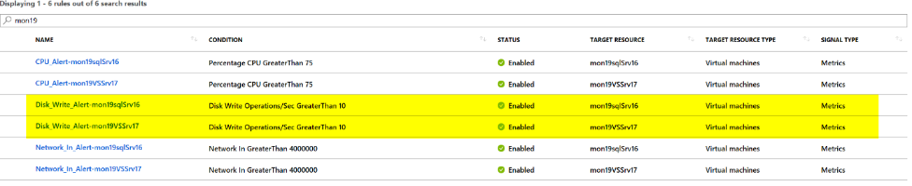

* Create a new Action Rule that suppress alerts from the scale set and virtual machines on Saturday and Sunday

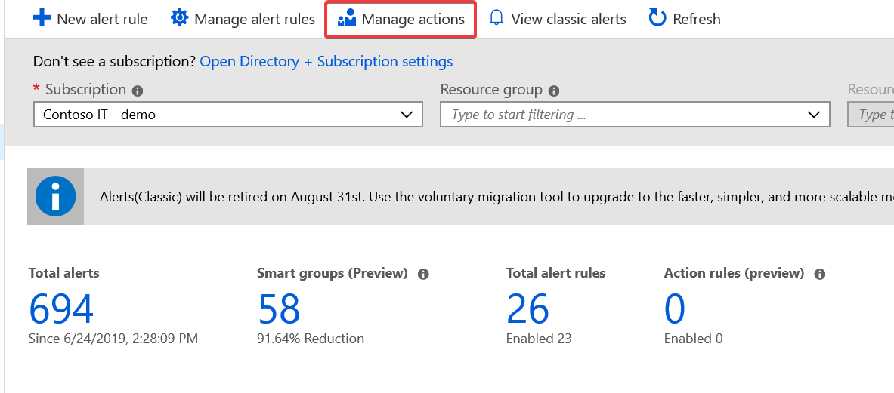  
Click on Manage actions

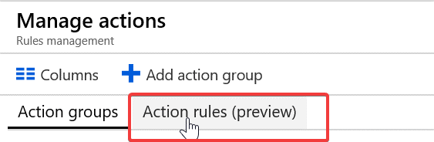  
Navigate to Action rules (preview)

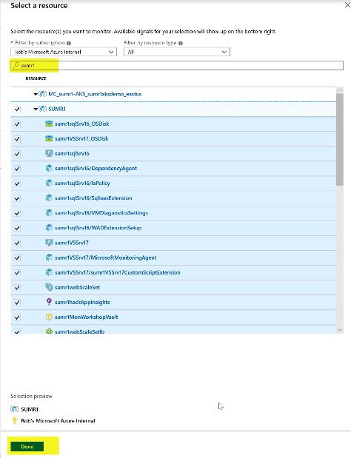

Under Scope, click on Select a resource and make sure you have your subscription selected. Then search for the name of the resource group that was created in the deployment of the workshop. Select your resource group when it comes up. Click Done

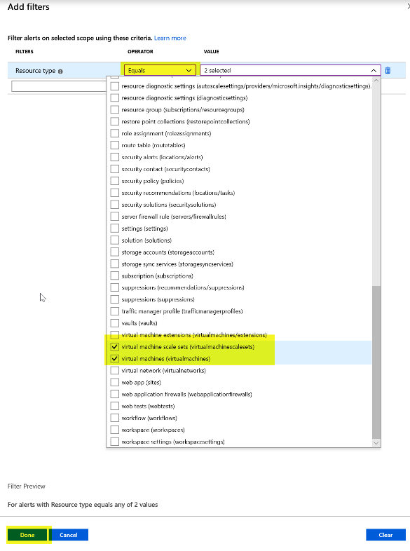

Under Filter Criteria, click on filters and select Resource type Equals Virtual Machines and Virtual Machine scales sets.

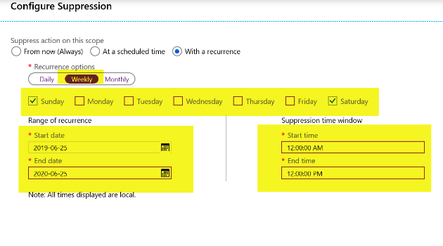

Under Suppression Config, click on Configure Suppression and configure the screen like the screen shot above.

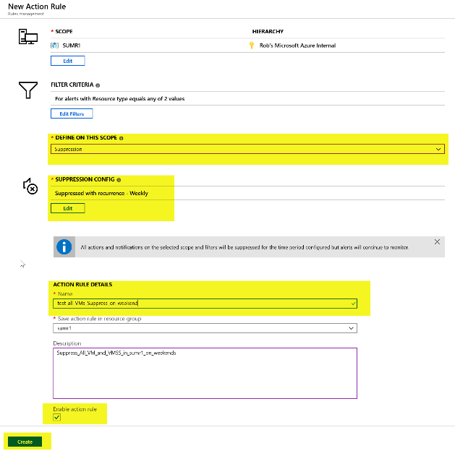

Add an Action Rule Name and Description, check off enable action Rule.

* First team to me a screenshot of the new Alert Rules and New Action Rule wins the challenge!!
* Good luck!

# Challenge 3: Application Insights

Enable Application Insights server-side telemetry in the eShopOnWeb Web Project in the Solution.

Hint: <https://docs.microsoft.com/en-us/azure/azure-monitor/app/asp-net-core#enable-application-insights-server-side-telemetry-no-visual-studio>

From the Visual Studio Server, navigate to C:\eshoponweb\eShopOnWeb-master and double-click on eShopOnWeb.sln

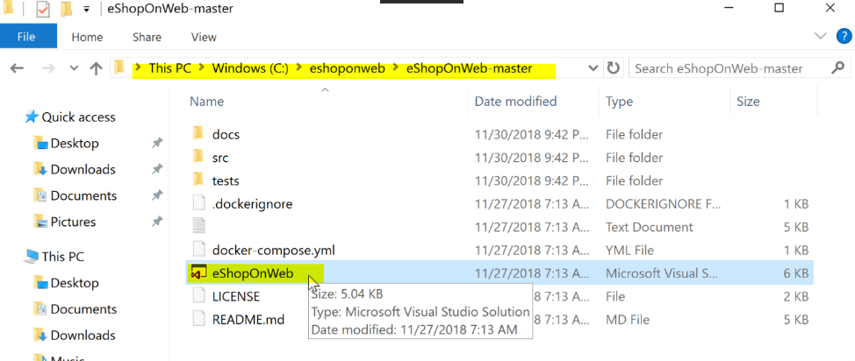

If this is the first time you are opening Visual Studio, please log in or create an account and log in.

Select Web

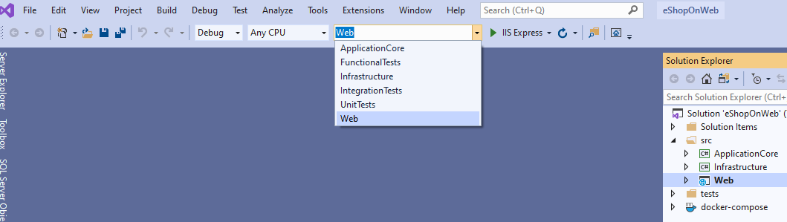

Right-click on Web in Solutions Explorer and select properties. Under Debug unselect the checkbox for Enable SSL.

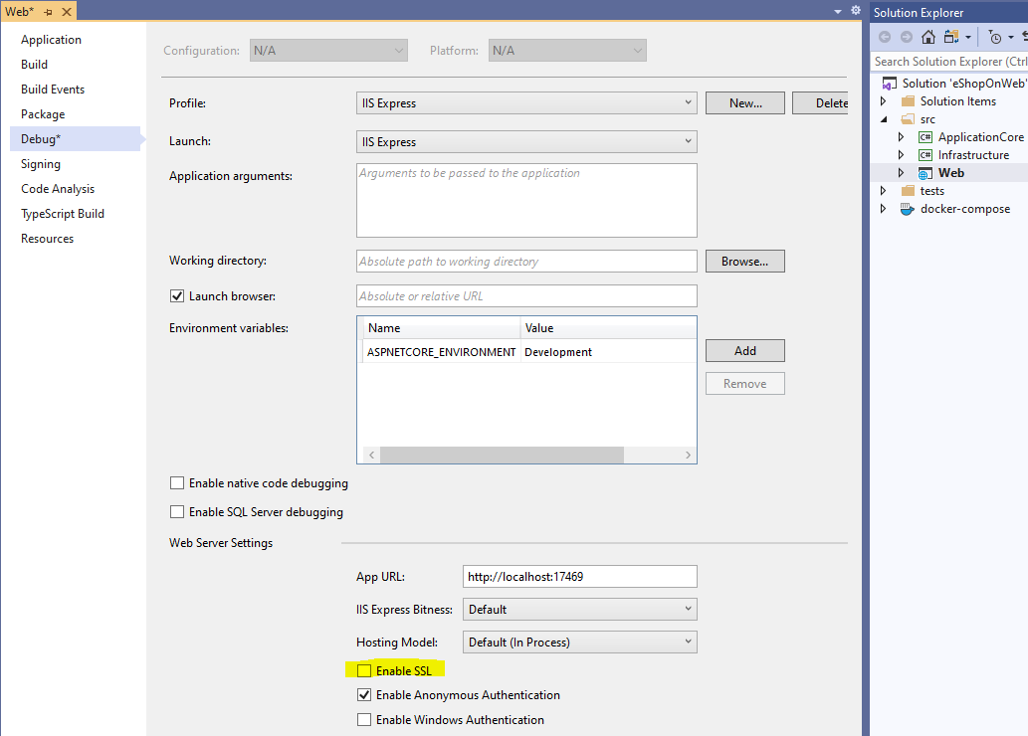

Click Save.

Click on IIS Express to test the eShopOnWeb application.



You should see the eShop app open locally. Close it and let’s Enable Application Insights server-side telemetry collection.

Install the Application Insights SDK NuGet package for ASP.NET Core. We recommend that you always use the latest stable version. Open Web.csproj and add the following line:

<PackageReference Include="Microsoft.ApplicationInsights.AspNetCore" Version="2.13.1" />

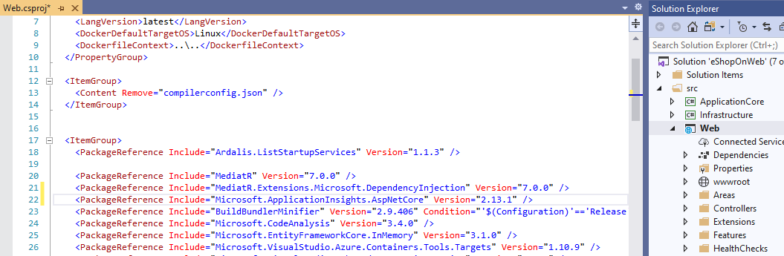

Add services.AddApplicationInsightsTelemetry(); to the ConfigureServices() method in your Startup class

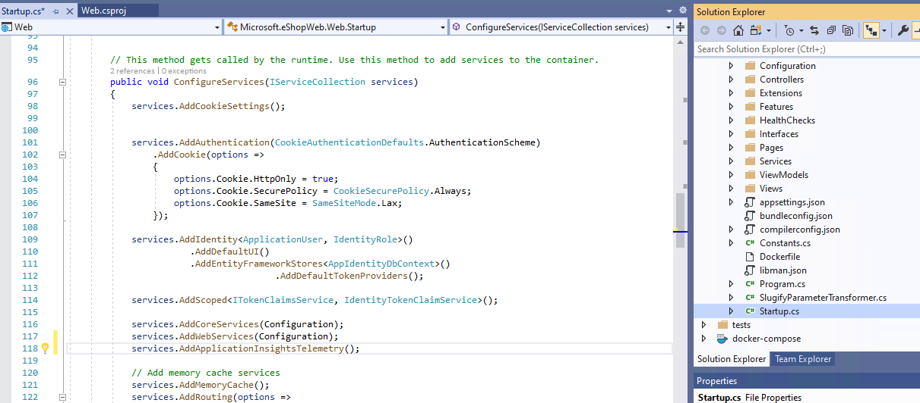

Specify an instrumentation key in appsettings.json

You can find your App Insights Instrumentation key in the Overview blade of your Application Insights resource in the Portal.

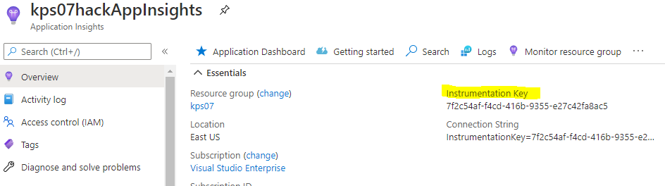

"ApplicationInsights": {

"InstrumentationKey": "putinstrumentationkeyhere"

},

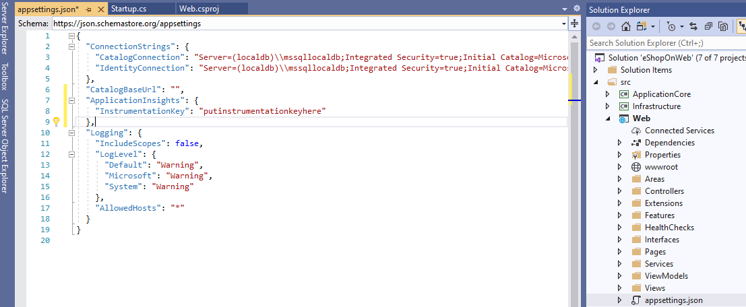

* + Run the eShopOnWeb Web project and check out the App Insights tooling

Test the application by running it and verify it’s working.

While its running you can navigate to Application Insights and view the telemetry while you are interacting with eShop running on the local machine. Add something to the shopping cart, log in and check out.

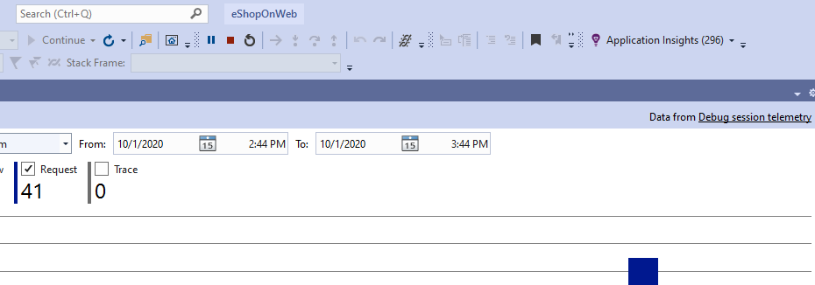

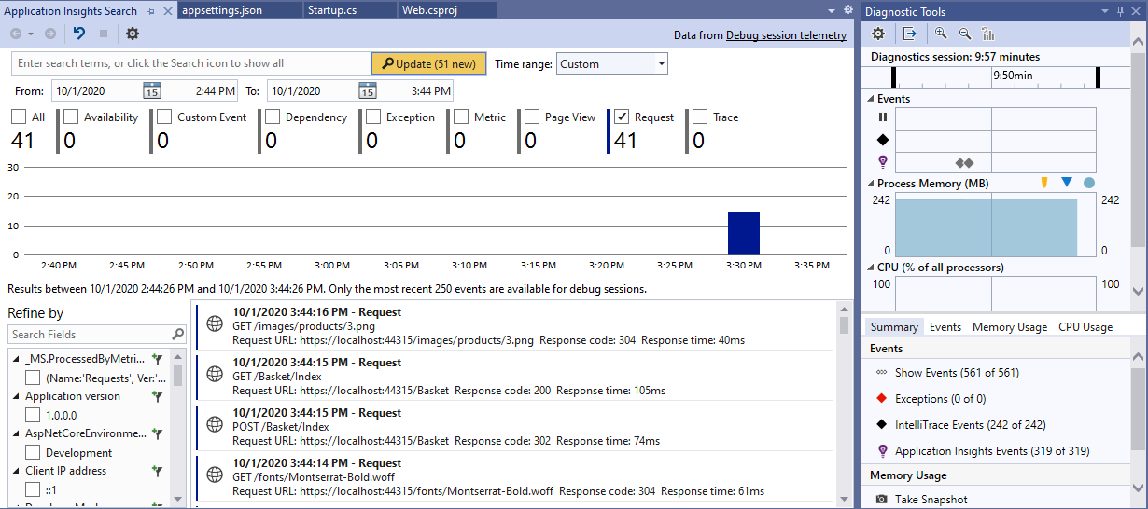

* + Generate some load and check out the results
  + Now you have the app running locally instrumented with Application Insights

To trip an exception in the app, login with the demo account provided and try to change your password.

1. Open your eShop site in your browser and login to the site running locally.  
   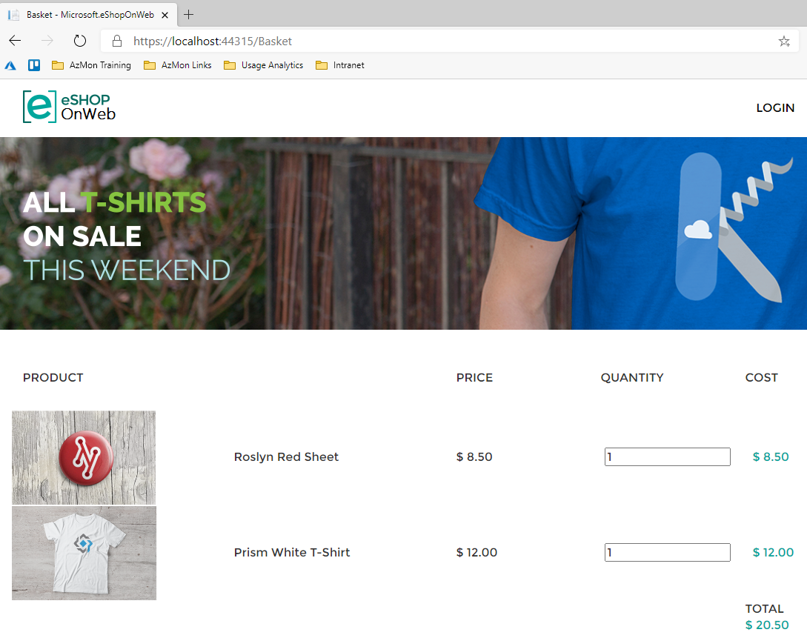  
   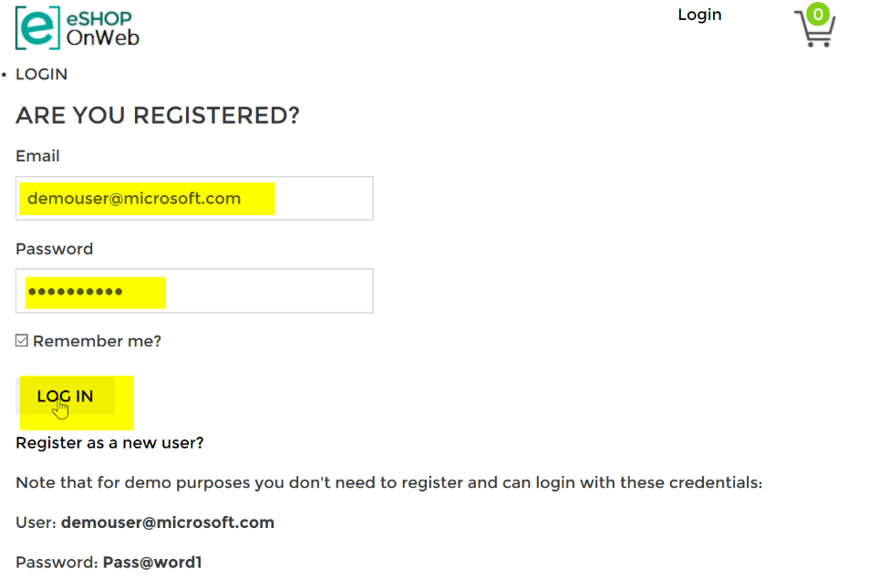
2. Try to change your password  
     
   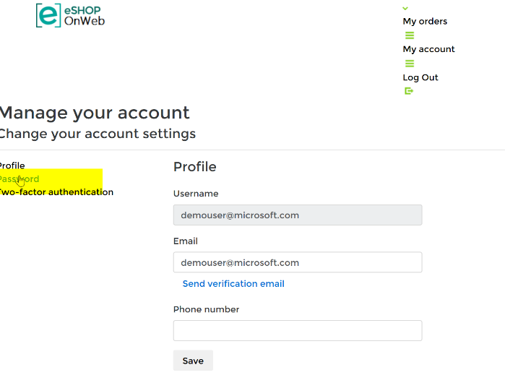

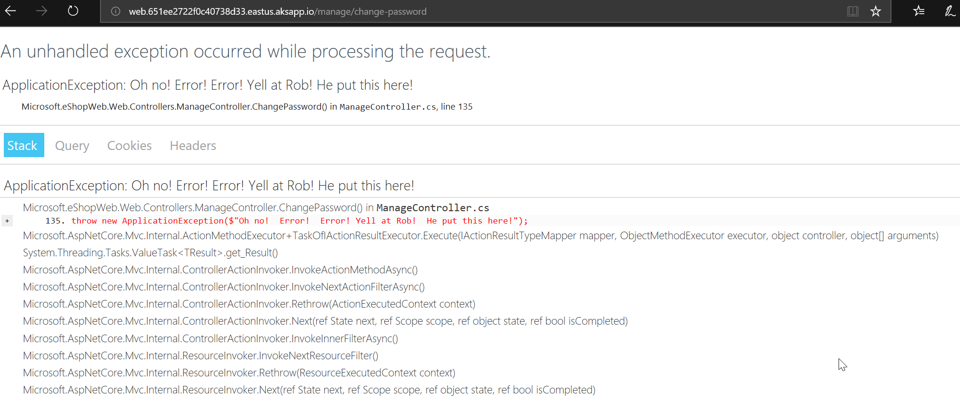

* + Find the exception in App Insights

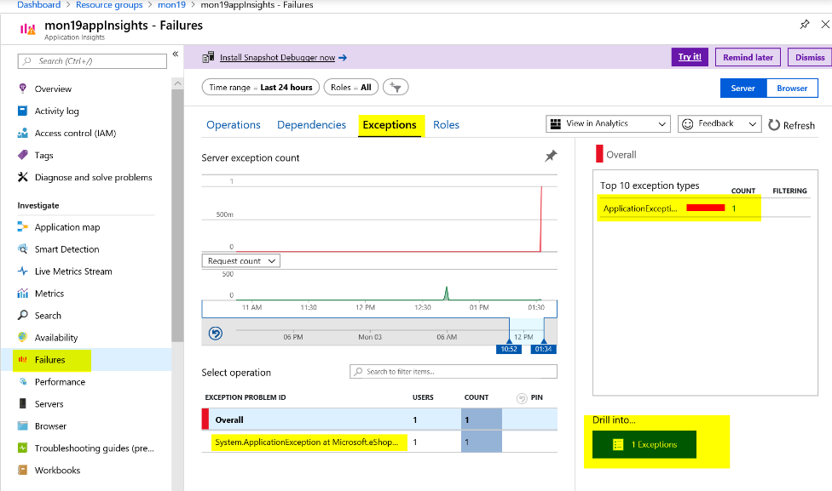

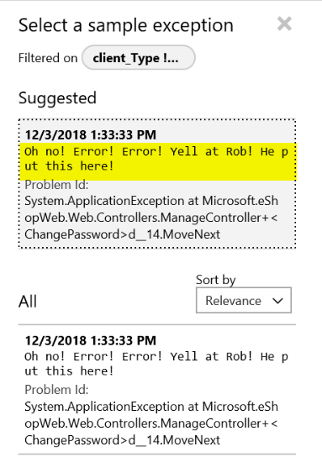

* Create Alerts based on Availability and exceptions

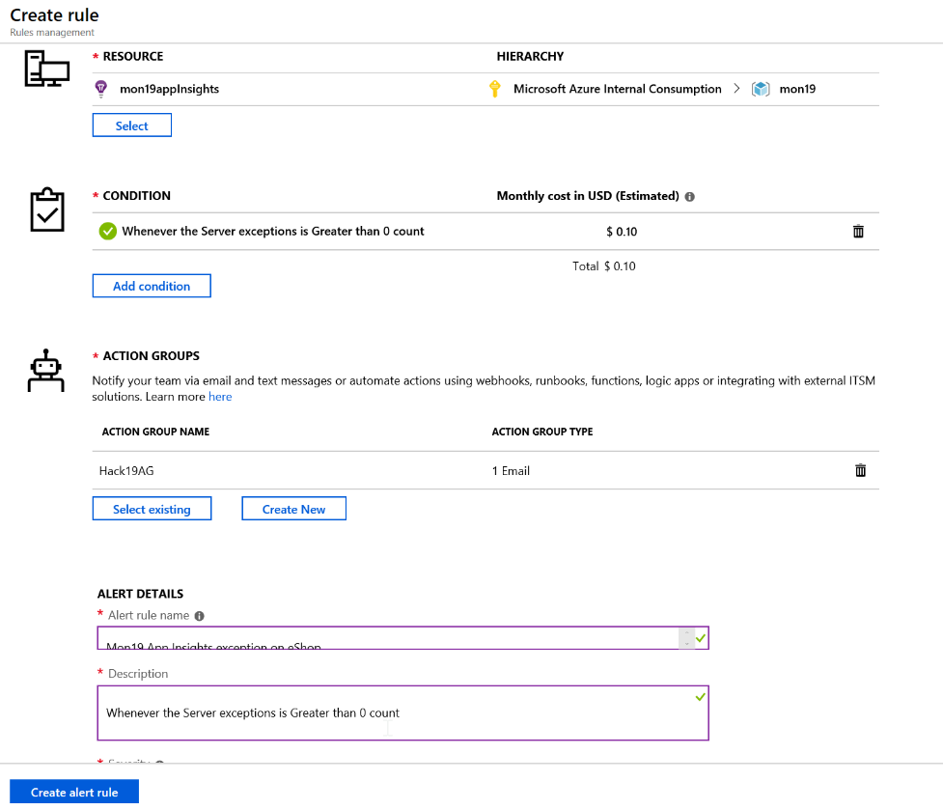

* First team to share a screenshot with the alert email of the exception based on the App Insights metric wins the challenge. Good luck.

**Client Telemetry**

Enable client-side telemetry collection for your eShoponWeb application.

Hint: <https://docs.microsoft.com/en-us/azure/azure-monitor/app/asp-net-core#enable-client-side-telemetry-for-web-applications>

Inject the App Insights .NET Core JavaScript snippet

Add the following line of code to Web\Views\ _ViewImports.cshtml

@inject Microsoft.ApplicationInsights.AspNetCore.JavaScriptSnippet JavaScriptSnippet

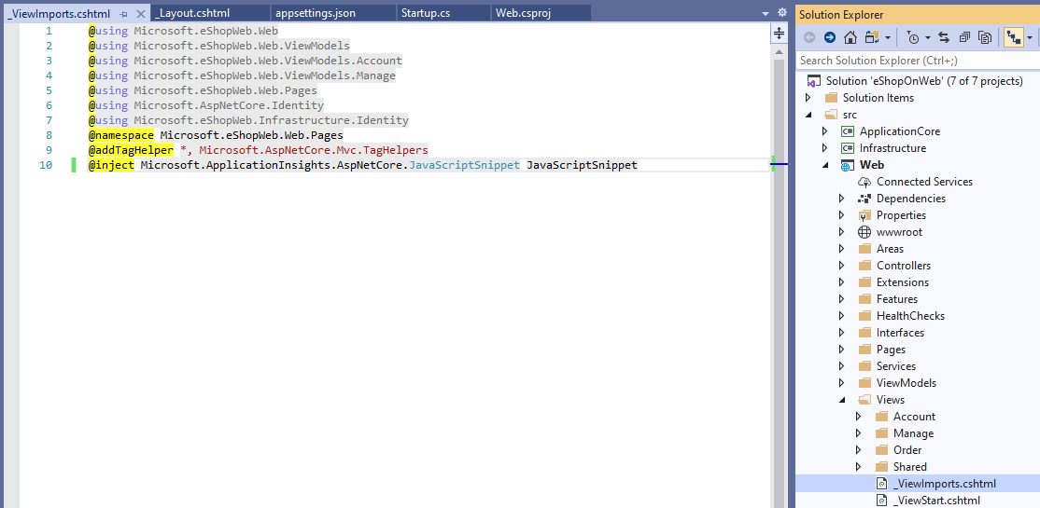

Insert HtmlHelper at the end of the <head> section in

Add the following line of code to Web\Views\Shared\_Layout.cshtml

@Html.Raw(JavaScriptSnippet.FullScript)

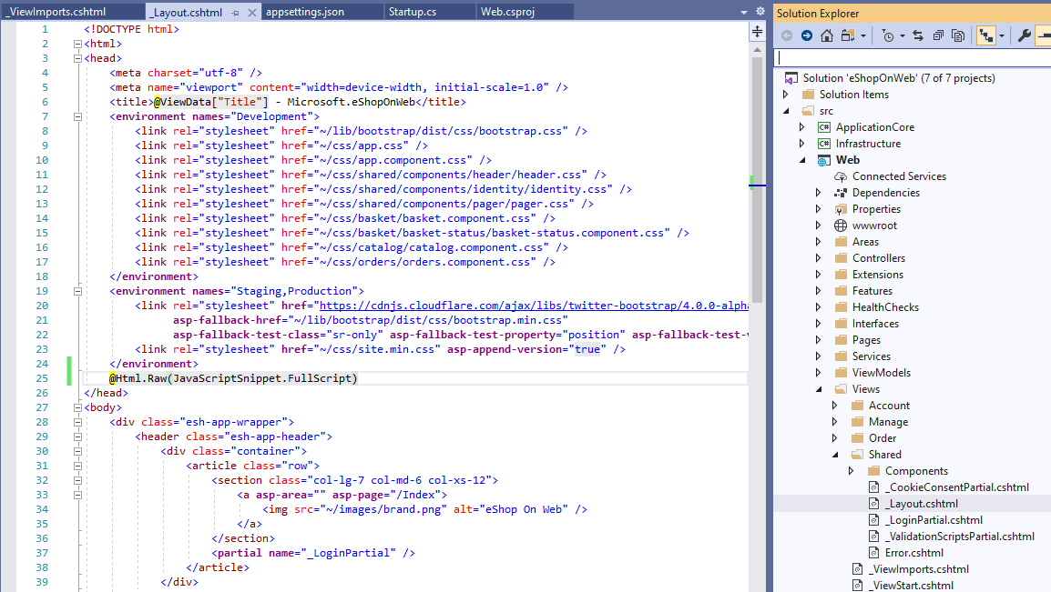

Run the app locally and explore a few pages to generate page views. After a few minutes, verify that page views are being collected by App Insights.

In the Portal, navigate to the Performance blade of your App Insights resource and switch the toggle from Server to Browser.

Stop the app running locally and save a copy of your updated Solution in a new location.

**Autoscale**

Your app is also hosted on the VMSS deployed as part of the workshop environment. Generate test load on the VMSS app url to cause a scale out event.

From your Visual Studio Server copy the code in the LoadScripts folder and modify it to your VMSS app URL

for ($i = 0 ; $i -lt 100; $i++)

{

Invoke-WebRequest -uri http:// mon19webscalesetlb.eastus.cloudapp.azure.com/

}

Run the code to generate some load on your eShopOnWeb site running on the VMSS. If the load is high enough, it may cause a scale out operation.

Share a screenshot with your scaleset scale out operation.

# Challenge 4: Azure Monitor for Containers

* From your Visual Studio Server, deploy the eShoponWeb application to AKS

Install Docker Desktop and restart your Visual Studio VM. This step is required before you can add Docker support to your eShoponWeb app in Visual Studio.

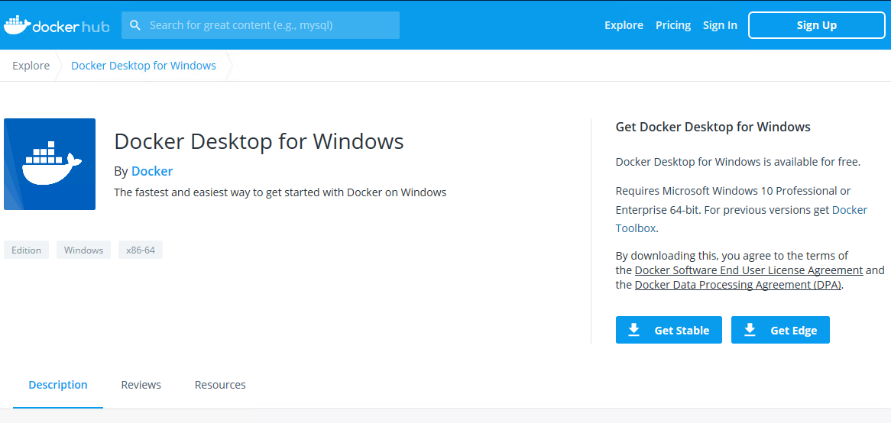

Complete the WSL 2 installation and restart Docker Desktop

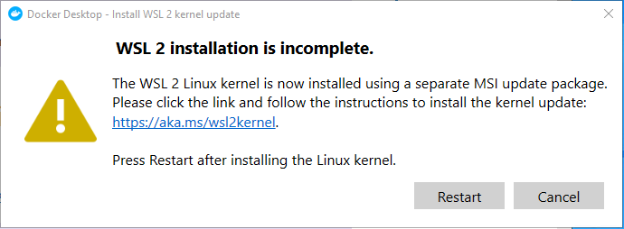

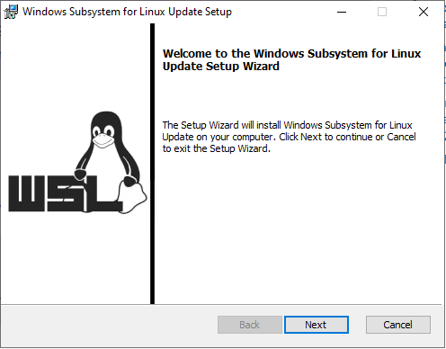

Navigate to c:\eshoponweb\eShopOnWeb-master

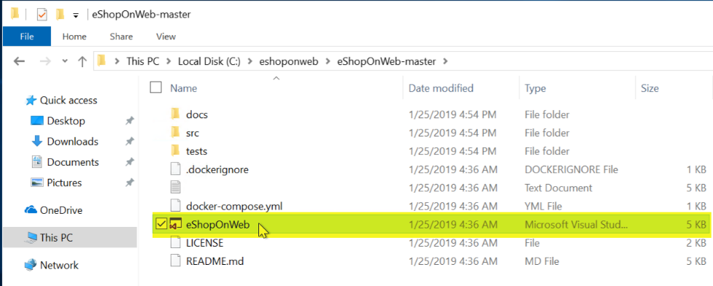

Double-click on eShopOnWeb.sln solution file and select Visual Studio 2019 when prompted.

Sign into Visual Studio if you have not already done so.

Once Visual Studio opens and settles down.

Update your DB connection strings in appsettings.json to use the SQL server IP address instead of hostname.

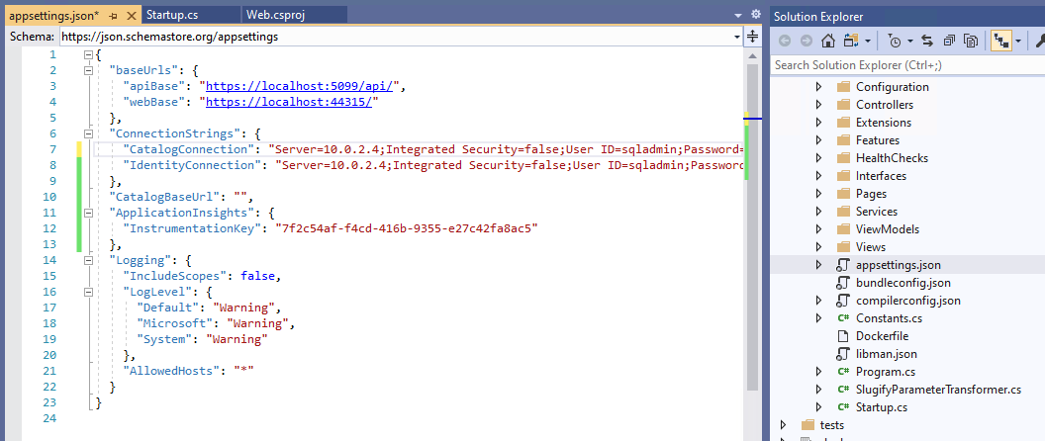

Right-click on Web and Add Docker Support. Leave the default option of Linux selected and click OK. Regenerate a new Dockerfile and wait for task to complete.

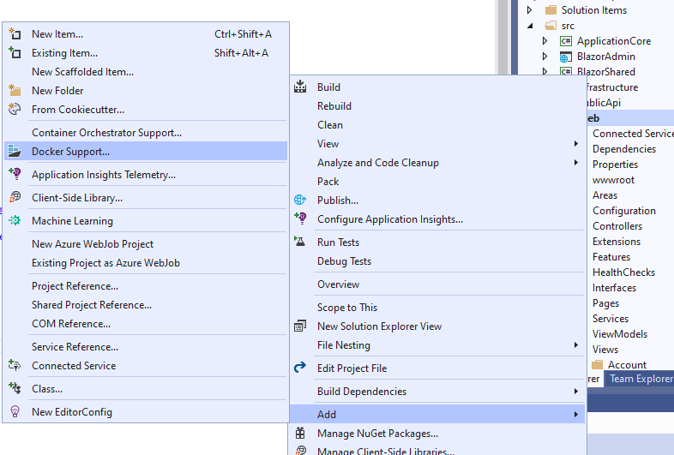

When prompted All your docker backend to communicate with Private Networks.

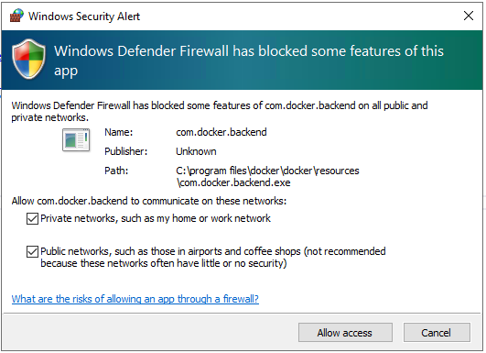

When Docker support has been added, you should see a Docker option to run/debug your app.

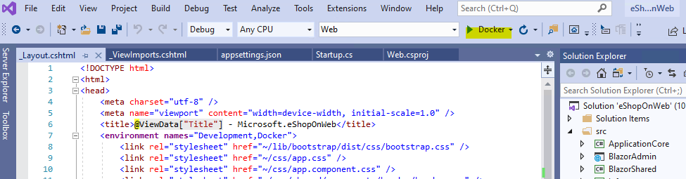

Click to run your app. Wait a few minutes for your app to build and load. When its complete Visual Studio will open the URL in the default browser. Your app is now running in a local container, click Stop.

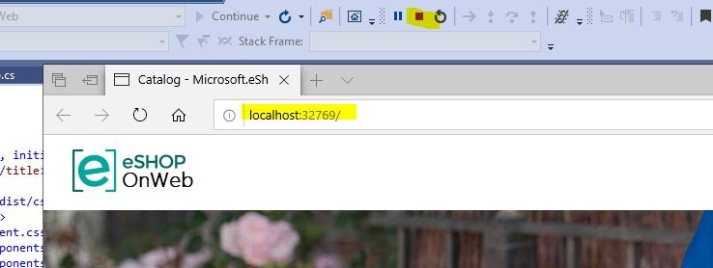

* From Azure Monitor, locate the container running the eShoponWeb application

Now, let’s move on to publishing the app to AKS.

Go to the Azure Portal and create an Azure Container registry with a Standard SKU in your workshop resource group.

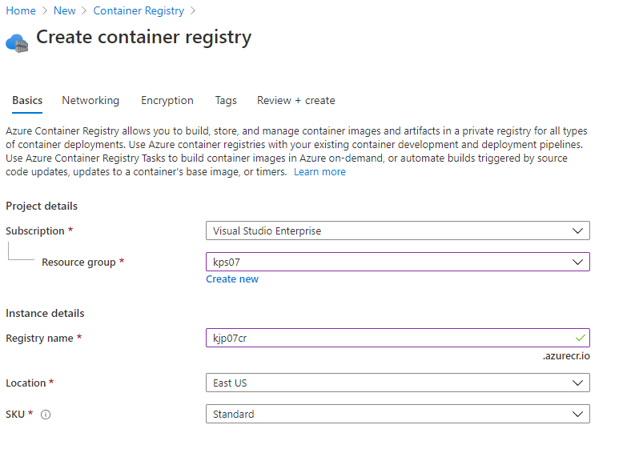

Once your Container Registry is created, return to Visual Studio and right click on Web to publish.

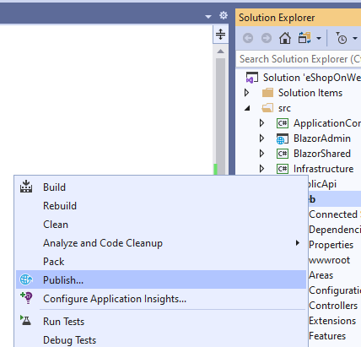

Choose Azure, Azure Container Registry as your Publish target and select the Container Registry that you just created. Click Finish.

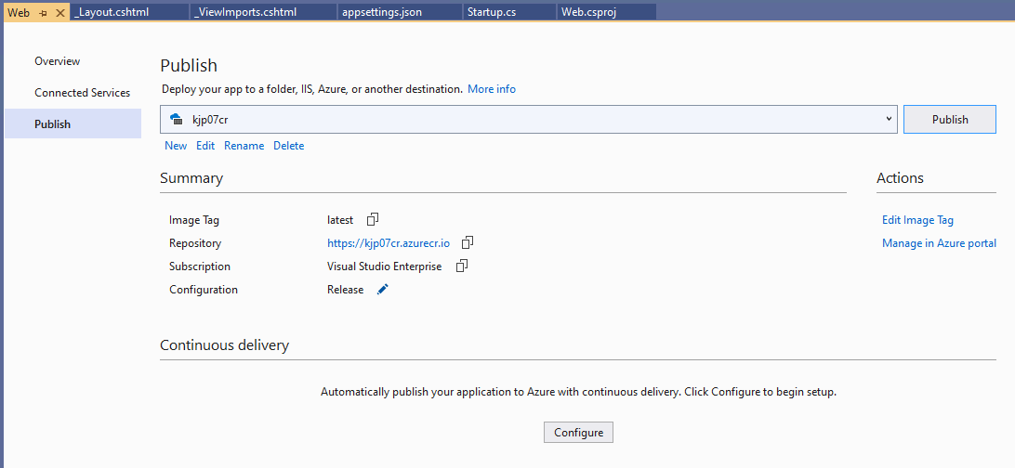

Next, navigate to the Connected Services for Web.

Configure Application Insights to Azure Application Insights, select your App Insights resource and **Save connection string in None**.

Configure SQL DB CatalogConnection to point to SQL Server Database, update connection string using the Catalog string found in appsettings.json and **Save connection string in None**.

Configure SQL DB IdentityConnection to point to SQL Server Database, update connection string using the Identity string found in appsettings.json and **Save connection string in None**.

Update Secrets.json(Local) **Ignore for all profiles**.

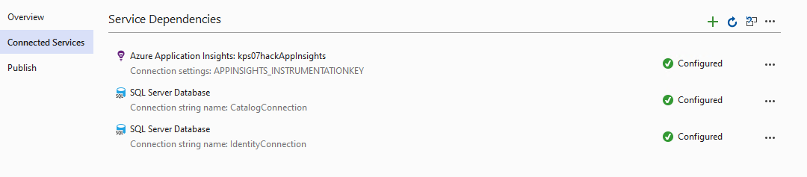

Return to Publish and click on Publish to push your app up to the Container Registry. This step will take several minutes. The final Visual Studio output should indicate successful push.

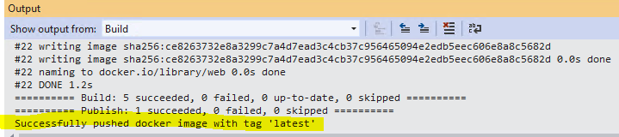

Open the provided deployment.yml file in Student\Resources and update the image name to point to your Container Registry Login server and image.

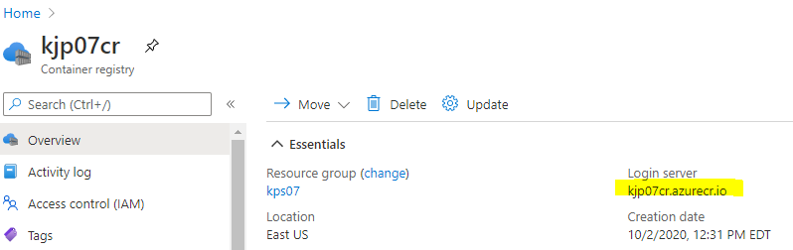

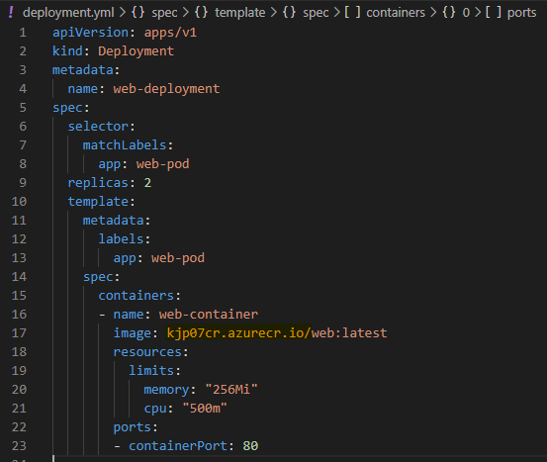

Upload the deployment.yml and service.yml files to your cloud shell.

Check connectivity to and the state of your AKS nodes

kubectl get nodes

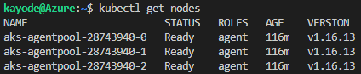

Run the following command to deploy your app

kubectl apply -f deployment.yml

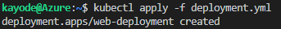

After a few minutes, check the status of your pods

kubectl get pods

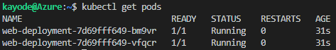

Run the following command to expose your app front-end on port 8080

kubectl apply -f service.yml

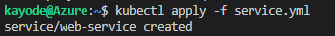

After a few minutes, check on the status of your service

kubectl get services

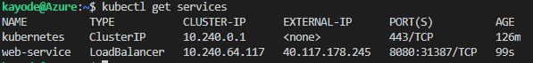

Use the external IP of the web-service and port 8080 to access your app deployed on AKS.

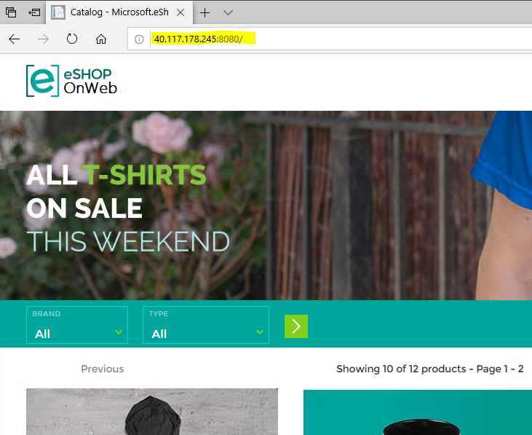

Return to the Azure Portal. From the Kubernetes service you created, click on Insights or you can navigate to Azure Monitor, click on Containers, and select your cluster.

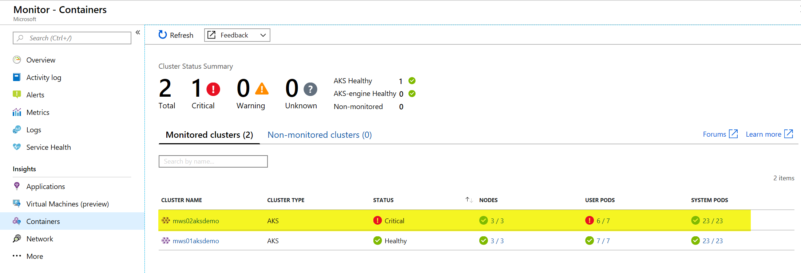

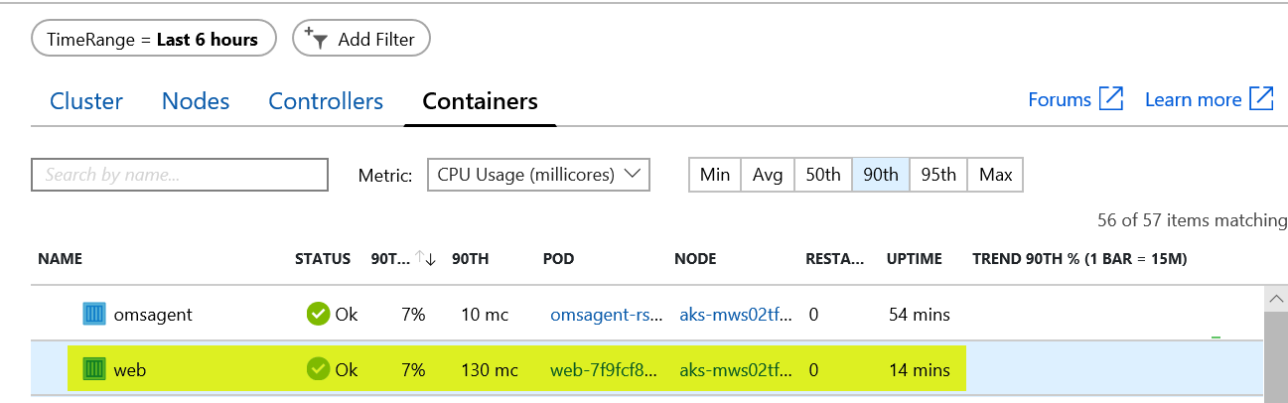

Or

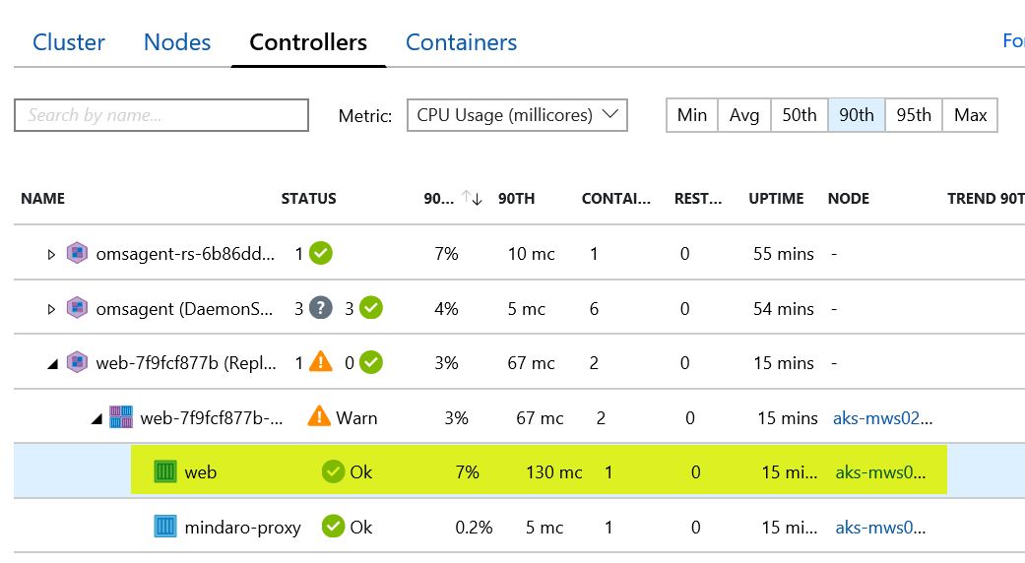

* Generate an exception in the eShoponWeb application  
  (Hint: Try to change your password, similar to the exception generated in the Application Insights challenge)

Login

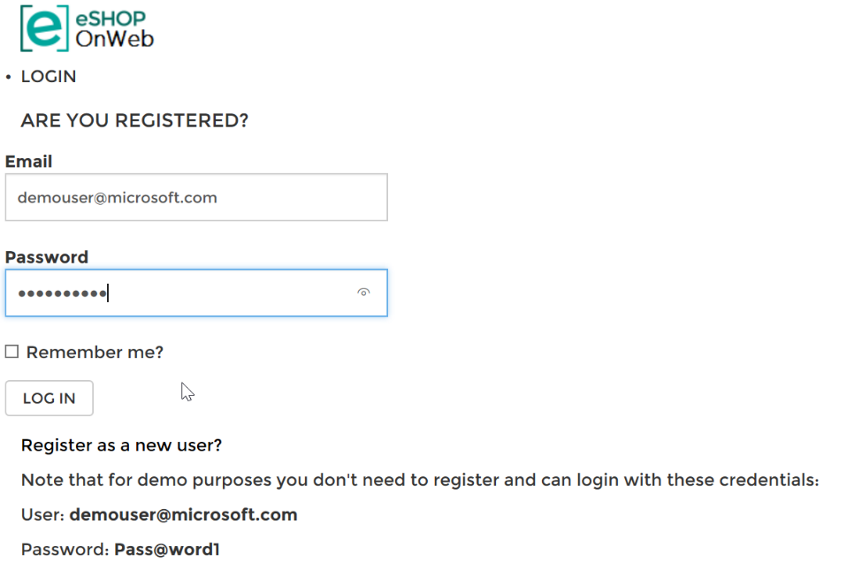

Enter the user and password provided on the page.

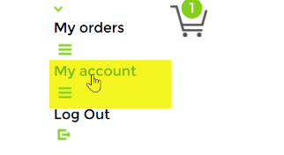

Click on My account

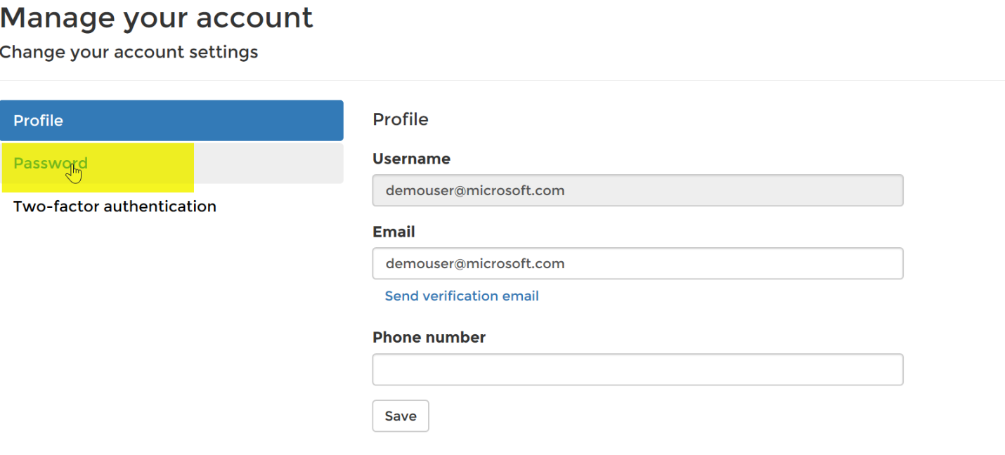

Click on Password

Notice an exception is thrown  


Click on the Web container and View container live logs.

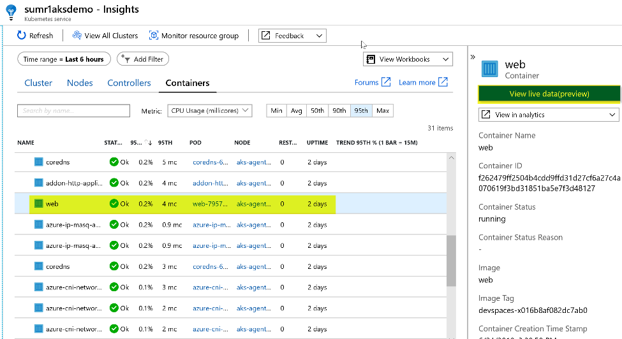

Trip the password exception again once the Status has gone from Unk to Ok.

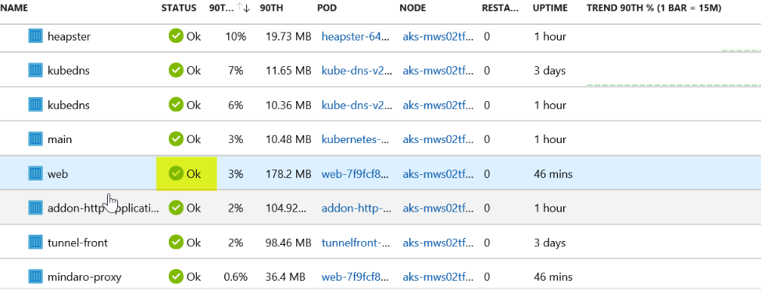

* First person to send me a screen shot of the live log with the exception message wins the challenge

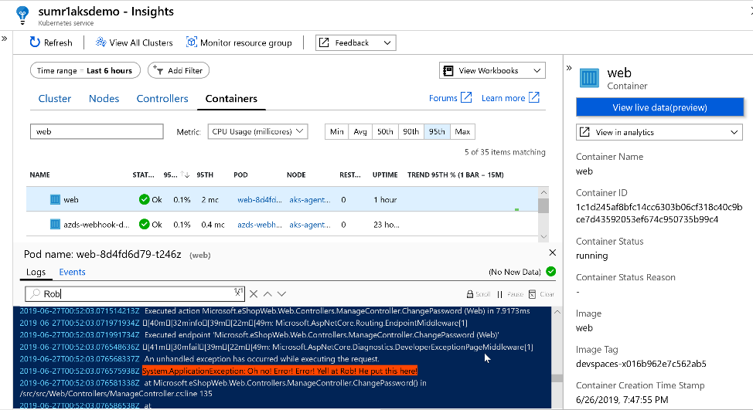

# Challenge 5: Log Analytics Query

Write a performance query that renders a time chart for the last 4 hours for both of the Web Servers and the SQL Server for the following perf metrics. Save each query to your favorites.

* + Processor Utilization: Processor / % Processor Time

Perf

| where ObjectName == "Processor" and CounterName == "% Processor Time" and TimeGenerated > ago(4h)

| summarize AVGPROCESSOR = avg(CounterValue) by bin(TimeGenerated, 5m), Computer

| sort by AVGPROCESSOR desc

| render timechart

* + Memory Utilization: Memory / % Committed Bytes In Use

Perf

| where ObjectName == "Memory" and CounterName == "% Committed Bytes In Use" and TimeGenerated > ago(4h)

| summarize AVGMEMORY = avg(CounterValue) by bin(TimeGenerated, 5m), Computer

| sort by AVGMEMORY desc

| render timechart

* + Disk Utilization (IO): Disk Reads/sec and Disk Writes/sec

Perf

| where CounterName == "Disk Reads/sec" and ObjectName == "LogicalDisk" and TimeGenerated > ago(4h)

| summarize AvgReadsDiskIO = avg(CounterValue) by bin(TimeGenerated, 5m), Computer

| sort by AvgReadsDiskIO desc

| render timechart

Perf

| where CounterName == "Disk Writes/sec" and ObjectName == "LogicalDisk" and TimeGenerated > ago(4h)

| summarize AvgDiskWritesIO = avg(CounterValue) by bin(TimeGenerated, 5m), Computer

| sort by AvgDiskWritesIO desc

| render timechart

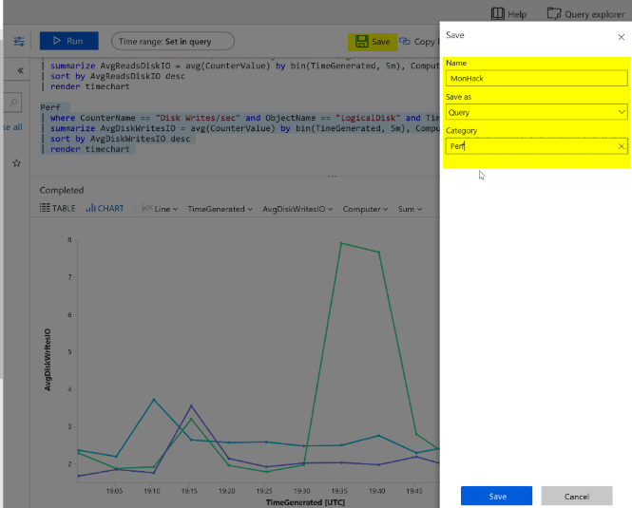

* Create a heartbeat query for Web and SQL Server

Heartbeat

| summarize max(TimeGenerated) by Computer

| where max_TimeGenerated < ago(15m)

| count

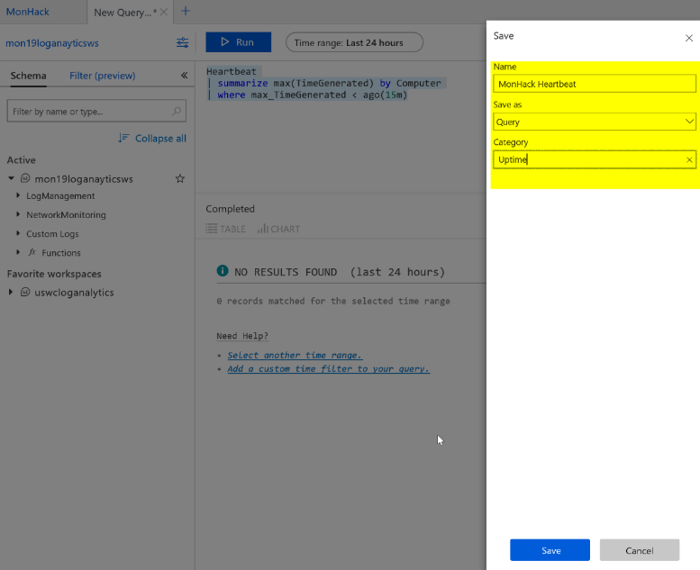

Write a performance query that renders a time chart for the last hour of the max percentage CPU usage of the AKS Cluster nodes

Solution 1 using maxif

// Declare time range variable

let timerange = 1h;

Perf

| where Computer startswith "aks"

| where TimeGenerated > ago(timerange)

//Aggregate maximum values of usage and capacity in 1 minute intervals for each node

| summarize CPUUsage = maxif(CounterValue, CounterName =="cpuUsageNanoCores"),

CPUCapacity = maxif(CounterValue,CounterName == "cpuCapacityNanoCores")

by bin(TimeGenerated, 1m), Computer

//Calculate Percent Usage

| extend PercentUsage = (CPUUsage / CPUCapacity) *100.0

| project TimeGenerated, PercentUsage, Computer

| render timechart

Solution 2 using let and join

//Store last 1hr snapshot of Perf table

let myPerf = materialize (Perf

| where Computer startswith "aks"

| where TimeGenerated > ago(1h));

//Store max CPU Usaqe per min values from Perf snapshot in usage table

let myUsage = myPerf

| where CounterName == "cpuUsageNanoCores"

| summarize CPUUsage = max(CounterValue) by bin(TimeGenerated, 1m), Computer;

//Store max CPU capacity per min values from Perf snapshot in capacity table

let myCapacity = myPerf

| where CounterName == "cpuCapacityNanoCores"

| summarize CPUCapacity = max(CounterValue) by bin(TimeGenerated, 1m), Computer;

//Join usage and capacity tables

myUsage

| join myCapacity on TimeGenerated, Computer

//Calculate percent usage

| extend PercentUsage = (CPUUsage / CPUCapacity) *100.0

| project TimeGenerated, PercentUsage, Computer

| render timechart

Combine infrastructure and application logs to create a single timeseries chart that includes:

* CPU usage from the node in your AKS cluster hosting the eshoponweb app
* Duration of page views on your eshoponweb app hosted on the cluster

Solution 1

// Declare time range variable

let timerange = 5h;

//Find the node running your eshoponweb app container

let myNode = ContainerInventory

| where Image == "web"

| distinct Computer;

let PercentTable = Perf

| where Computer in (myNode)

| where TimeGenerated > ago(timerange)

//Aggregate maximum values of usage and capacity in 1 minute intervals for each node

| summarize CPUUsage = maxif(CounterValue, CounterName =="cpuUsageNanoCores"),

CPUCapacity = maxif(CounterValue,CounterName == "cpuCapacityNanoCores")

by bin(TimeGenerated, 1m)

//Calculate Percent Usage and rename TimeGenerated

| extend PercentUsage = (CPUUsage / CPUCapacity) *100.0, timestamp = TimeGenerated

| project timestamp, PercentUsage;

//Add AppInsights Data

let AppInsights = app("kjp17hackAppInsights").pageViews

| where timestamp > ago(timerange)

| summarize responsetime = avg(duration) by bin(timestamp, 1m)

| extend responsetimeseconds = responsetime / 1000.0

| project timestamp, responsetimeseconds;

// Join Percent Usage and AppInsights

PercentTable

| join AppInsights on timestamp

| project timestamp, PercentUsage, responsetimeseconds

| render timechart

Solution 2 with hardcoding node name and using let and join statements

// Declare time range variable

let timerange = 5h;

//Store snapshot of Perf table for the node where the app container is running

let myPerf = materialize ( Perf

| where TimeGenerated > ago(timerange)

| where Computer == "aks-agentpool-10755307-2"

);

//Store Usage Values

let myUsage = myPerf

| where CounterName == "cpuUsageNanoCores"

| summarize CPUUsage = max(CounterValue) by bin(TimeGenerated, 1m);

//Store Capacity Values

let myCapacity = myPerf

| where CounterName == "cpuCapacityNanoCores"

| summarize CPUCapacity = max(CounterValue) by bin(TimeGenerated, 1m);

//Calculate Percentage and rename TimeGenerated to timestamp

let Percent = myUsage

| join myCapacity on TimeGenerated

| extend PercentUsage = (CPUUsage / CPUCapacity) *100.0, timestamp = TimeGenerated

| project timestamp, PercentUsage;

//Add AppInsights Data

let AppInsights = app("kjp17hackAppInsights").pageViews

| where timestamp > ago(timerange)

| summarize responsetime = avg(duration) by bin(timestamp, 1m)

| extend responsetimeseconds = responsetime/1000.0

| project timestamp, responsetimeseconds

| sort by timestamp asc;

// Join Percent Usage and AppInsights

Percent

| join AppInsights on timestamp

| project timestamp, PercentUsage, responsetimeseconds

| sort by timestamp asc

| render timechart

# Challenge 6: Dashboard and Analytics

* Deploy Grafana using Web App for Container

<https://github.com/grafana/azure-monitor-datasource/blob/master/README.md>

* + Hint: <http://docs.grafana.org/installation/docker/>

Create a Web App for Linux and configure as recommended below.

Create a new App service plan and select B1 Basic. It’s under Dev / Test.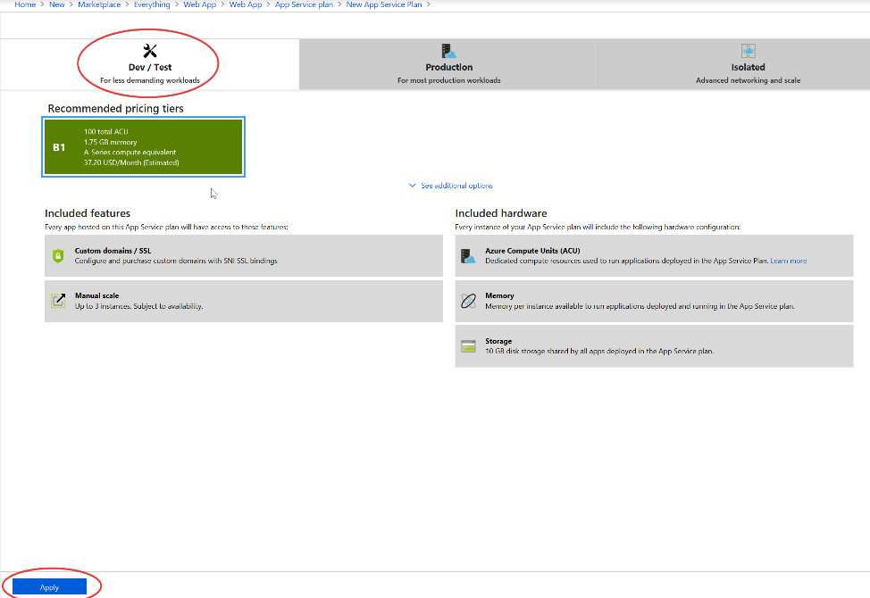  
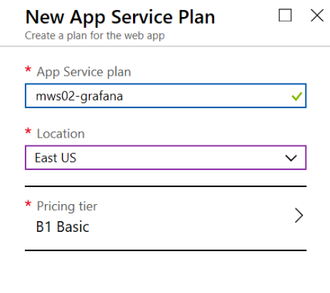

Select Container and specify Docker Hub, Public and Grafana/Grafana for the image (this should deploy the latest version by default)  
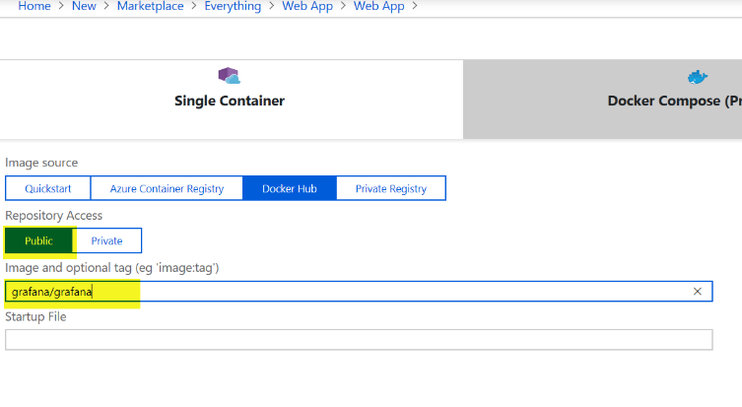

Should look like this when complete:  
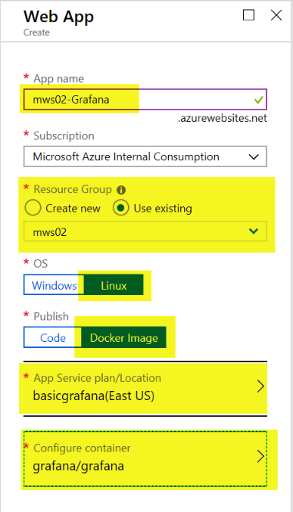

Click Create

After the Web App deploys, we need to configure some settings to enable Azure Monitor Plugin.

From the Azure Portal navigate to your newly created App Service, Settings, Application Settings

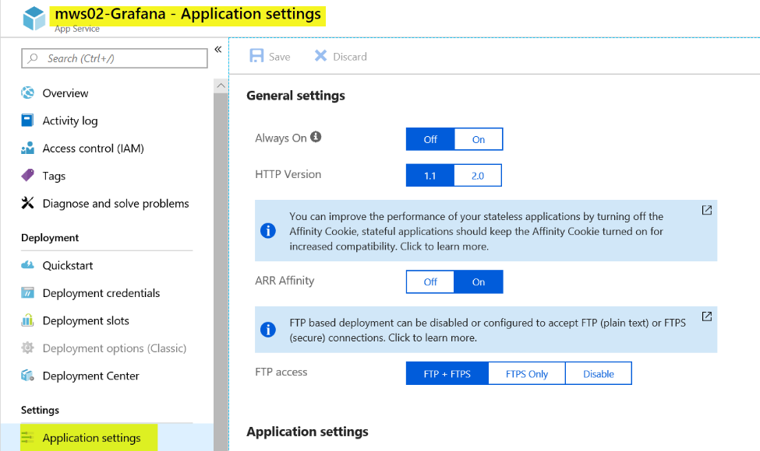

Under Always On, change the value to On.

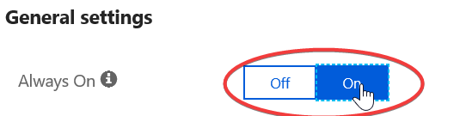

Under Application Settings, click on Show Values

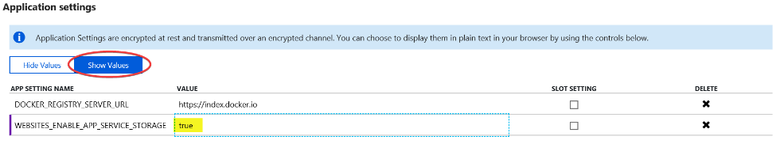

Change the value for WEBSITES_ENABLE_APP_SERVICE_STORAGE to true (from false)

Click Add new Setting and add the following:

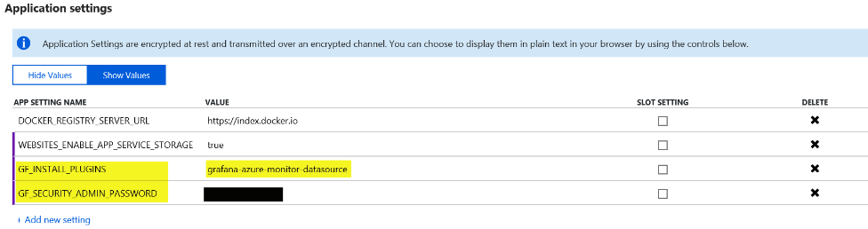

Click Save

Note: For the Application settings to take effect you may need to restart your Web App

**To Login to Grafana**

Click on Overview and copy the URL for your Web App

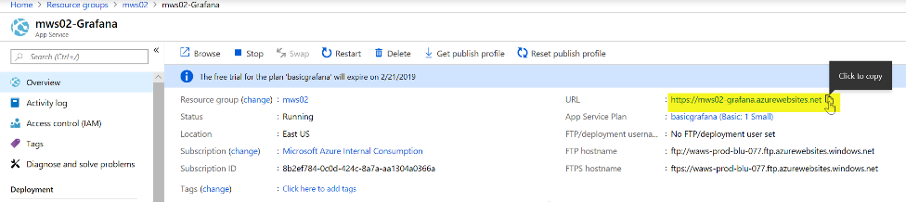

Navigate to the URL in your browser

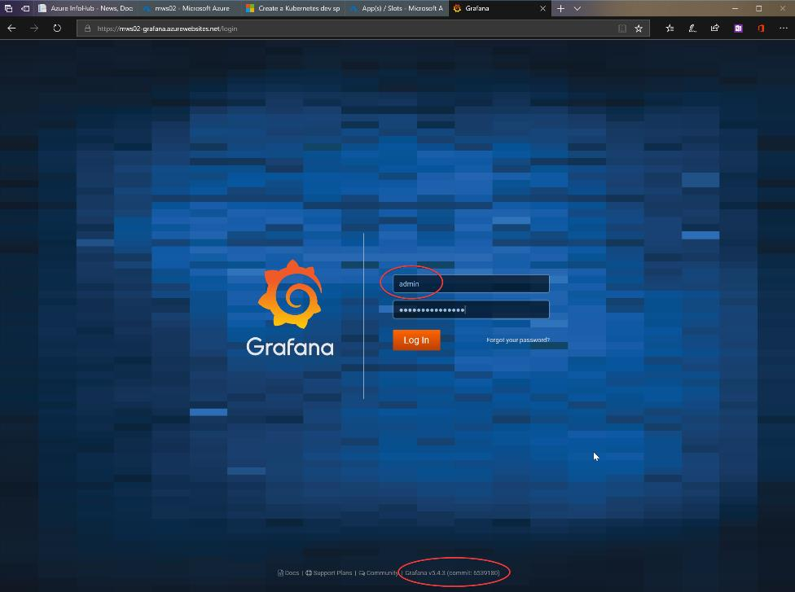

The username is “admin” lowercase and the password is whatever you configured in Application Settings. Notice the version of Grafana as you need 5.2.0 or newer if you are querying Azure Log Analytics.

Once logged into Grafana you should notice Azure Monitor is installed  
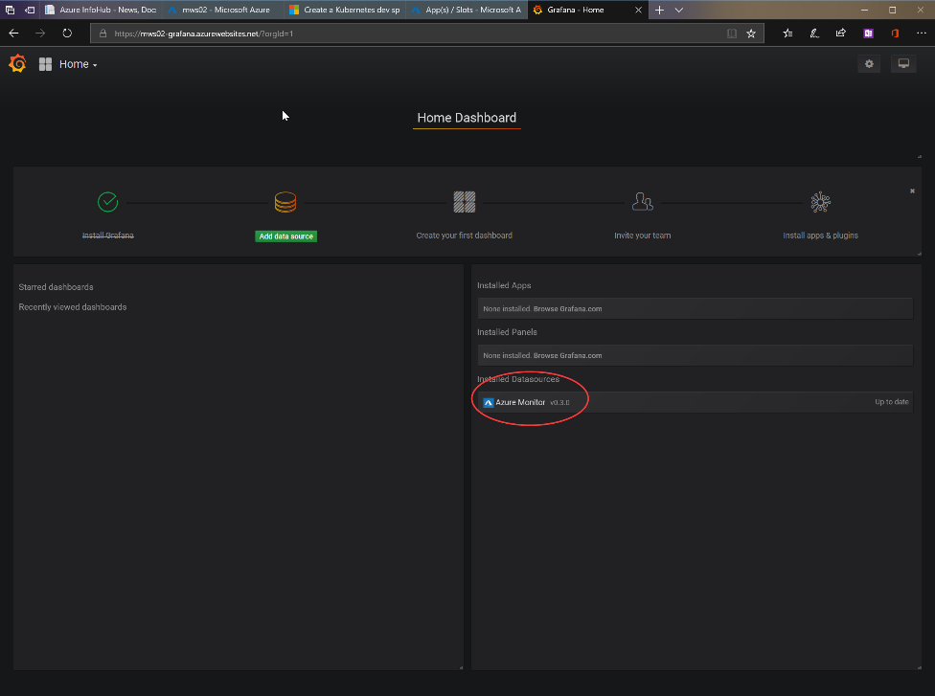

* Configure the Azure Monitor Data Source for Azure Monitor, Log Analytics and Application Insights

Configure Azure Monitor data source

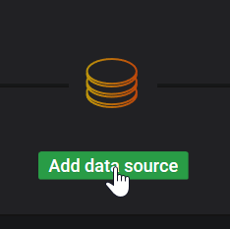

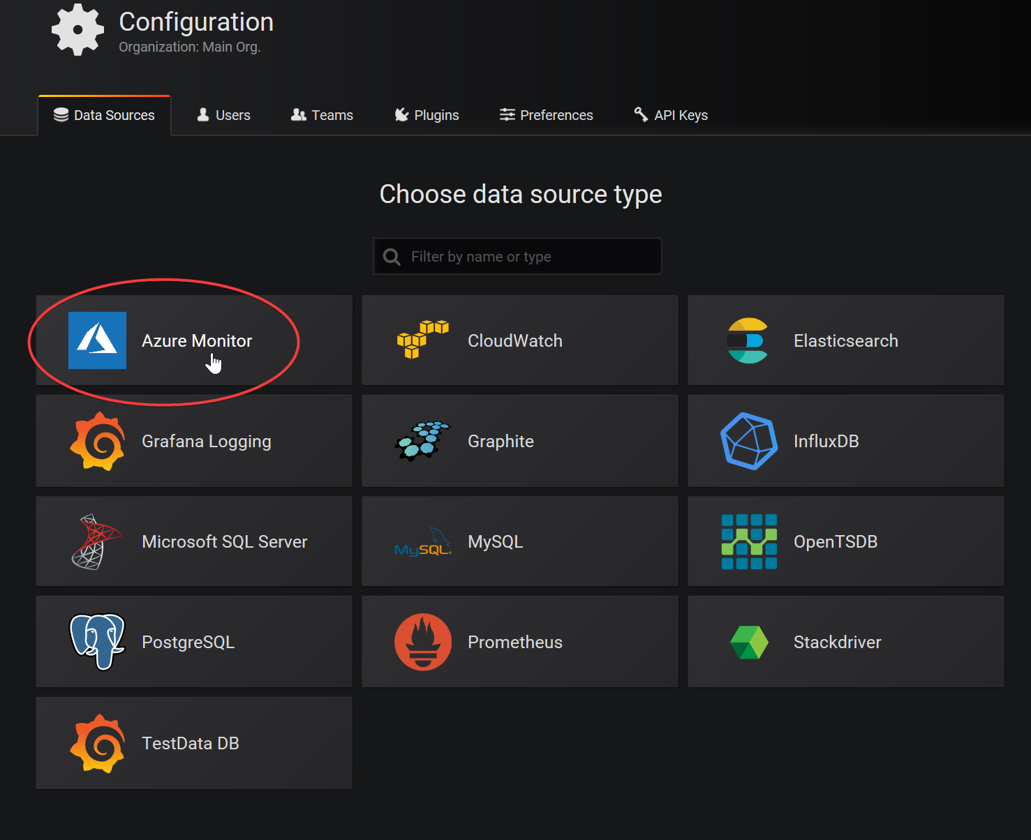

Fill out the Azure Monitor API Details

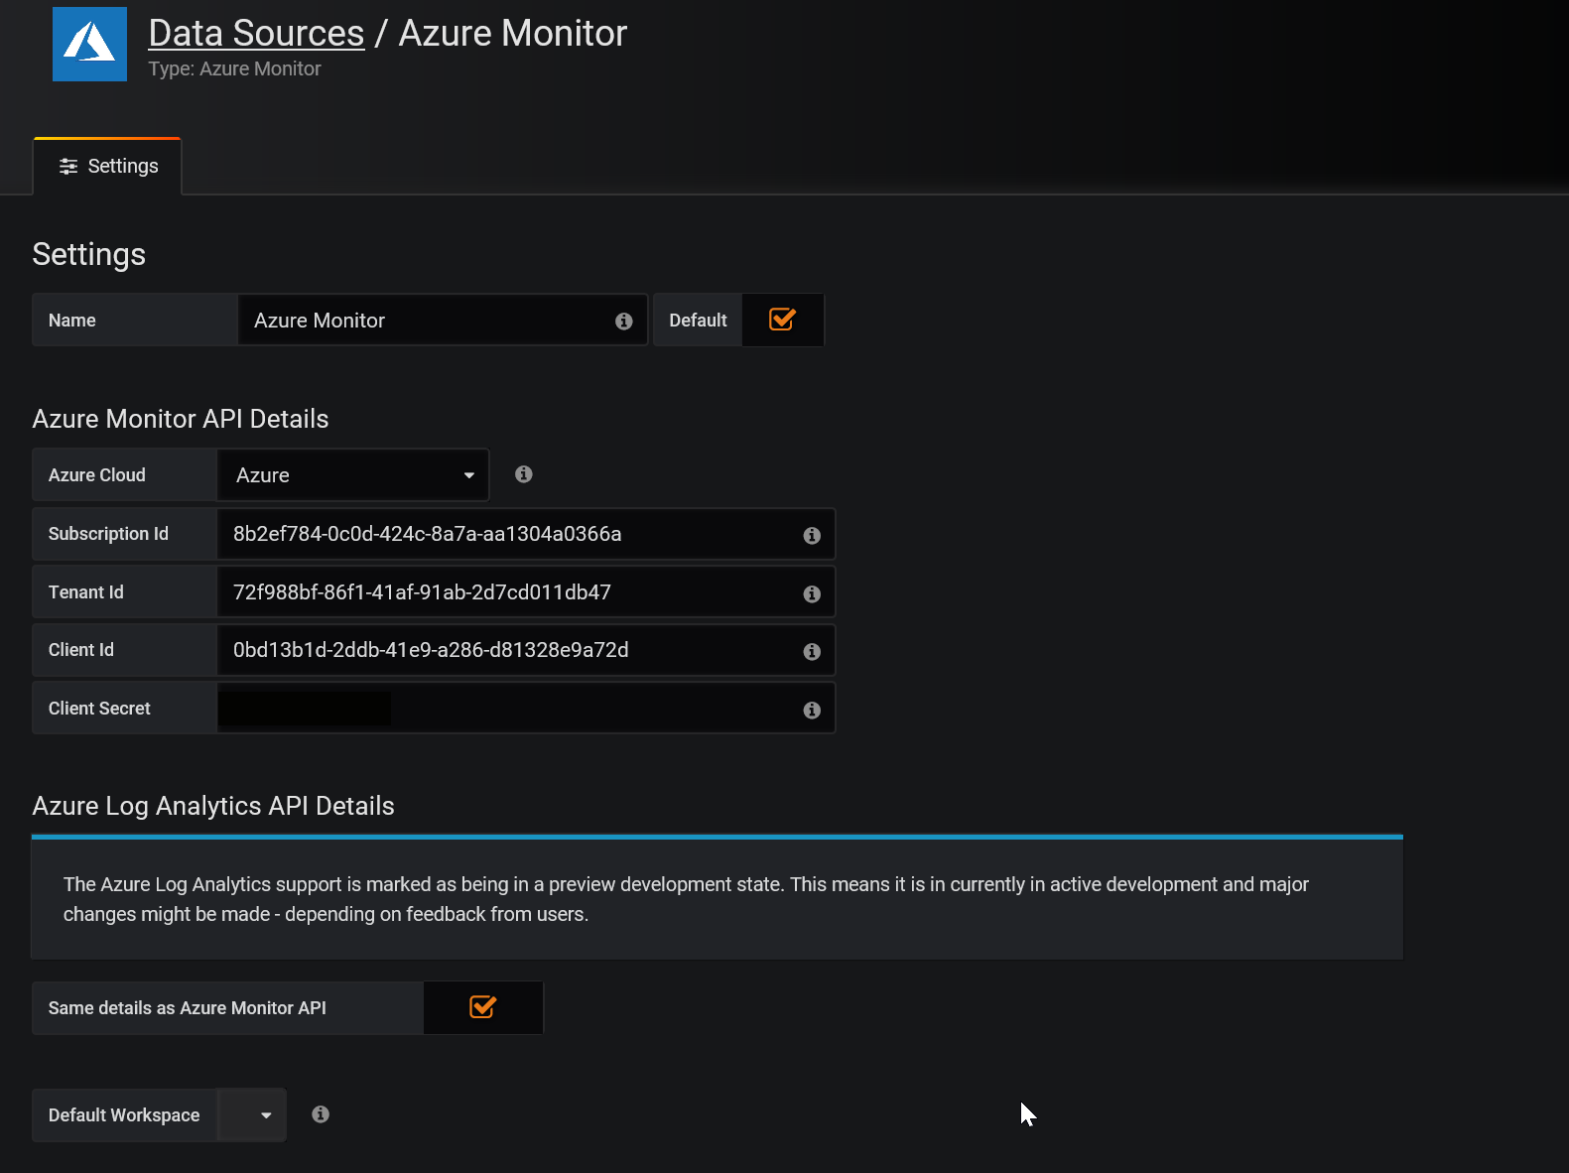

For Tenant Id, go to Azure AD, properties to find the Directory ID.

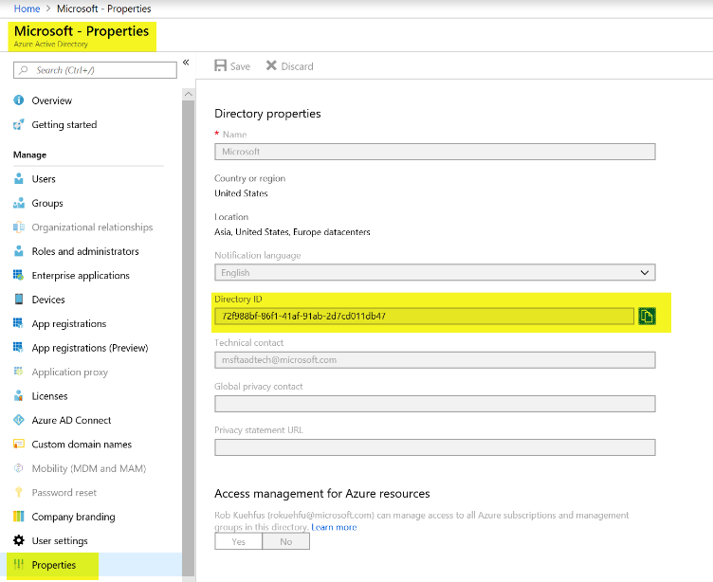

For Client Id, use the same client Id (Service Principal) you used in the AKS deployment for terraform. Note: Azure best practices would be to generate a new service principal and only grant the required permissions.

Sample: ready-mws02-aks-preday Client Id = 0bd13b1d-2ddb-41e9-a286-d81328e9a72d

For Client Secret, use the same password you set in the Azure Key Vault during the deployment

Note: Make sure to add the service principal created during the deployment to your Log Analytics as a reader

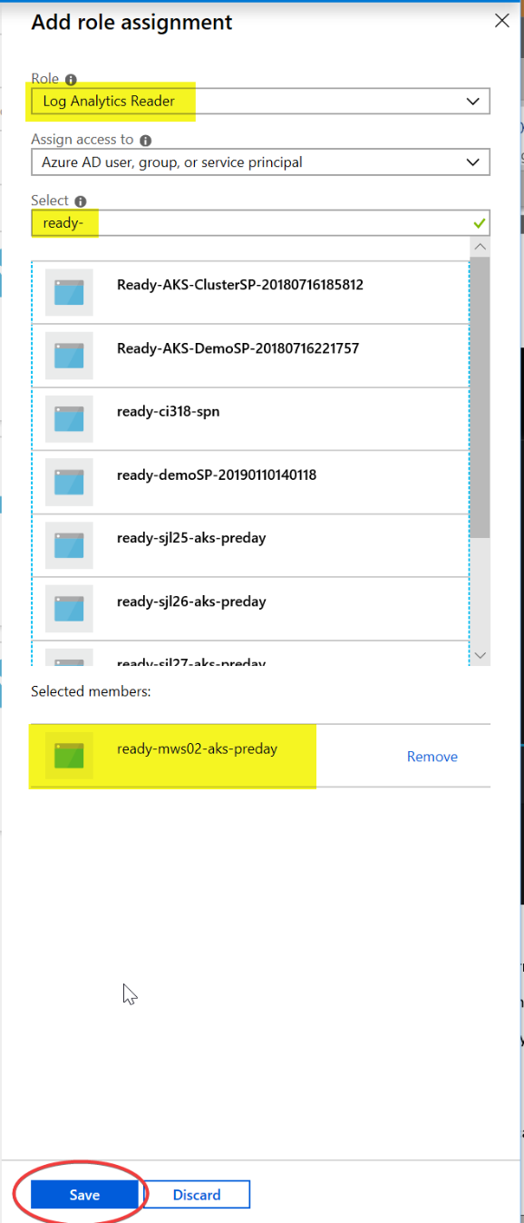

Click Save & Test and you should see a message like below.

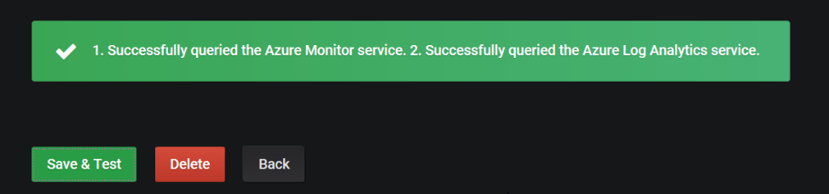

To configure Application Insights, find your API Id and generate a key

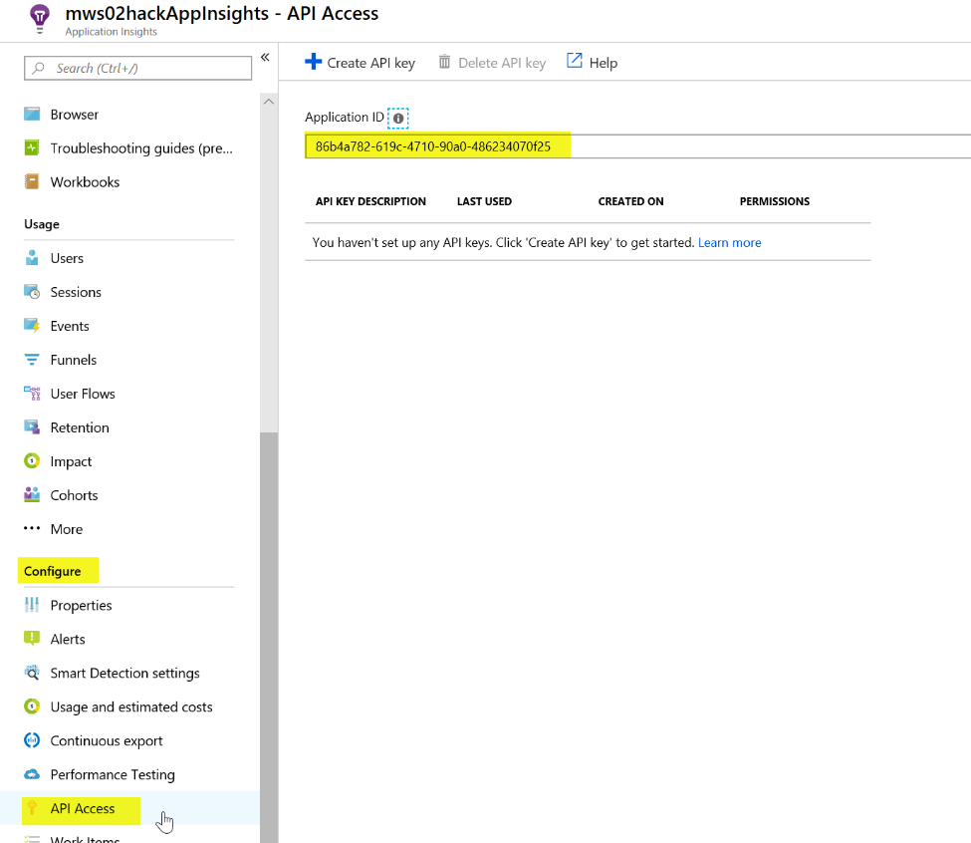

Copy the Application ID and paste in Grafana. Click on Create API Key

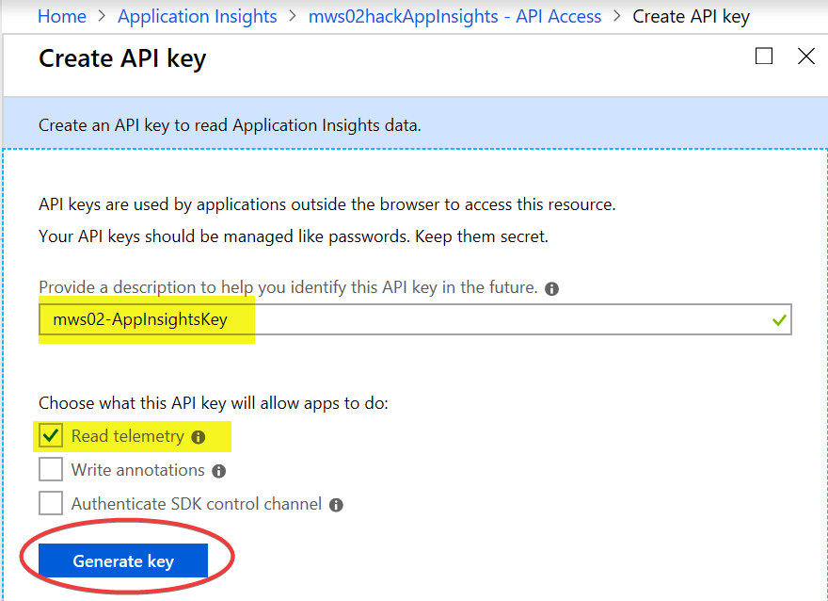

Copy the key and paste in the Grafana Application Insights Details. Note: you cannot retrieve this key again.

Click Save & Test. Should like this now.

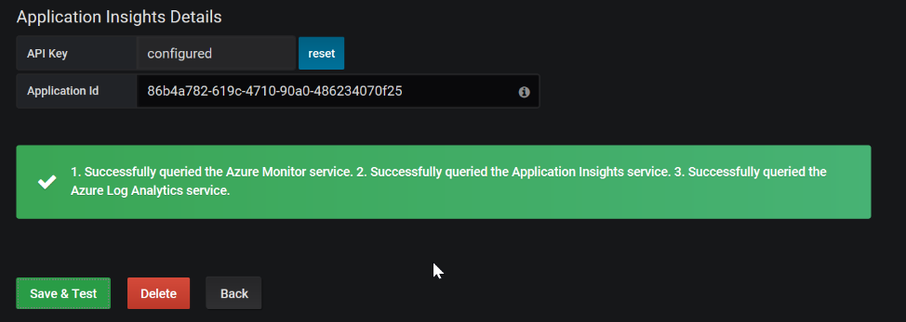

* Create a CPU Chart with a Grafana variable used to select Computer Name

Create a new dashboard

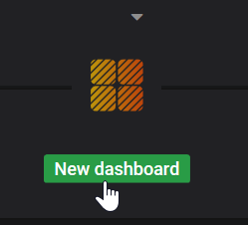

Add Graph

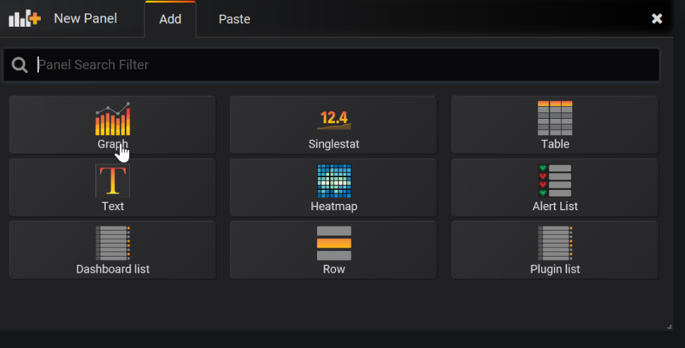

Edit the Panel Title

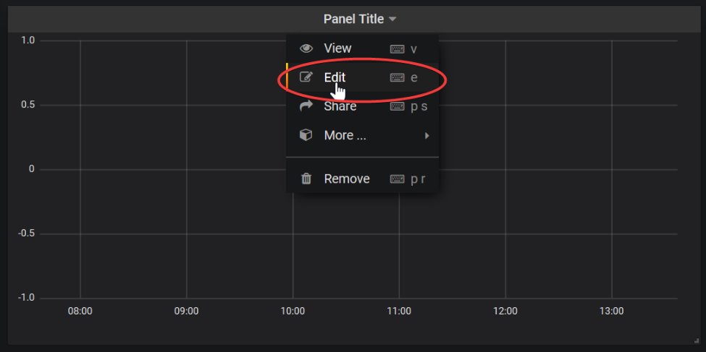

Under General change to the name to something like Computer CPU

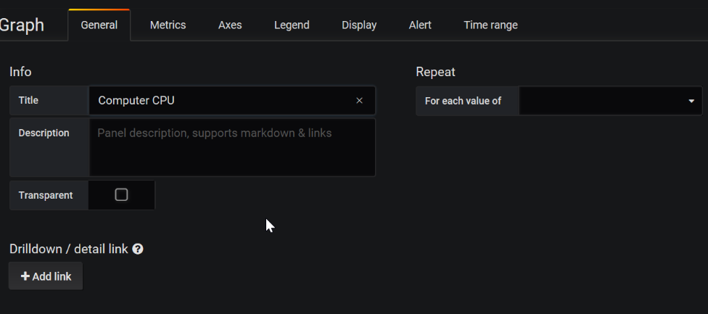

Under Metrics, make sure service is Azure Log Analytics, your workspace is selected, and build out a Log Analytics query (answer query below for your reference).

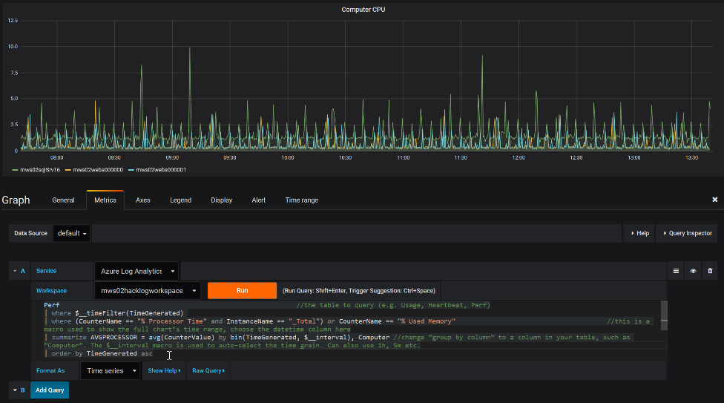

Sample query:

Perf

| where $__timeFilter(TimeGenerated)

| where CounterName == "% Processor Time" and InstanceName == "_Total"

| summarize percentile(CounterValue,50) by bin(TimeGenerated, $__interval), Computer

| order by TimeGenerated asc

Click Run to test

Now let’s make a few changes. Click on Axes and change the Unit to percent and Y-Max to 100.  
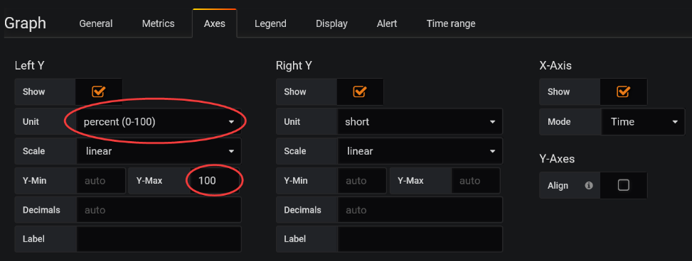

Run it again

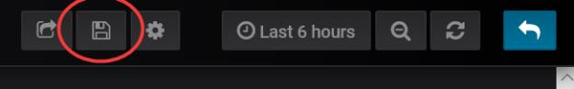

Let’s save it by click on the disk in the upper right side.

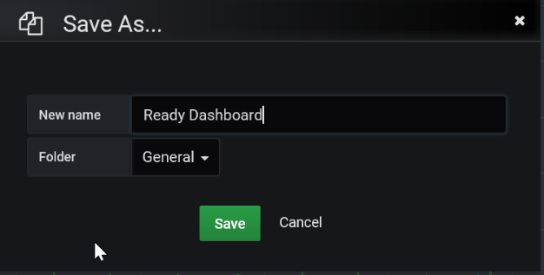

Should look something like this:

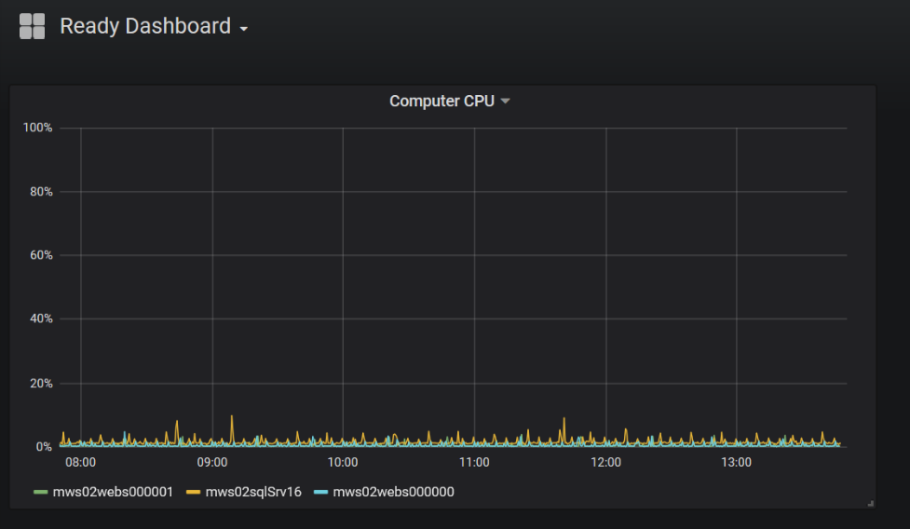

Advanced features

* **Variables**

Some query values can be selected through UI dropdowns, and updated in the query.

For example, a “Computer” variable can be defined, and then a dropdown will appear on the dashboard, showing a list of possible values:

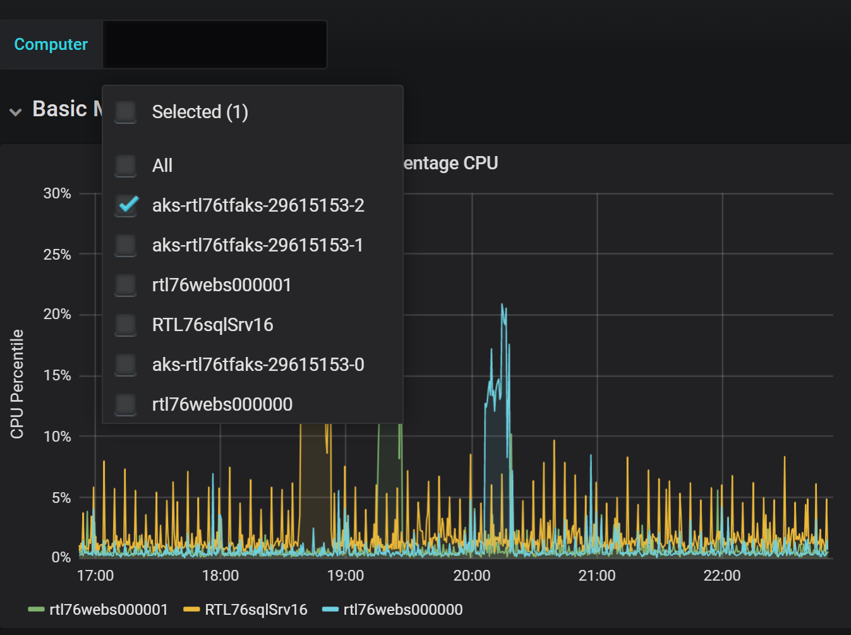

Now let’s add a variable that lets us select computers in the chart. Click on the gear in the upper right corner.  
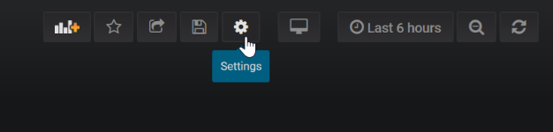

Click on Add Variable

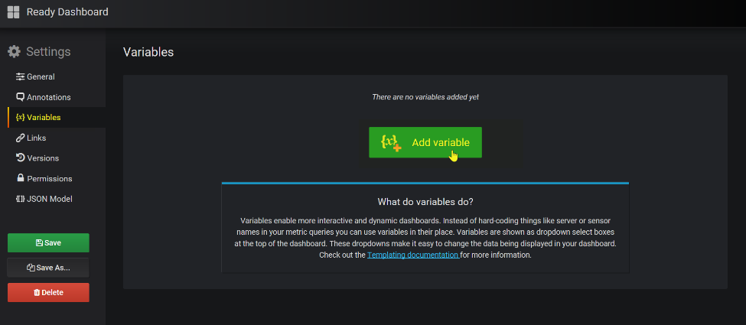

Configure the Variable to look like the screen below. Note: In my case I make sure to specify the Workspace name as I have many workspaces and wanted to make sure we only returned values that would work in our chart.

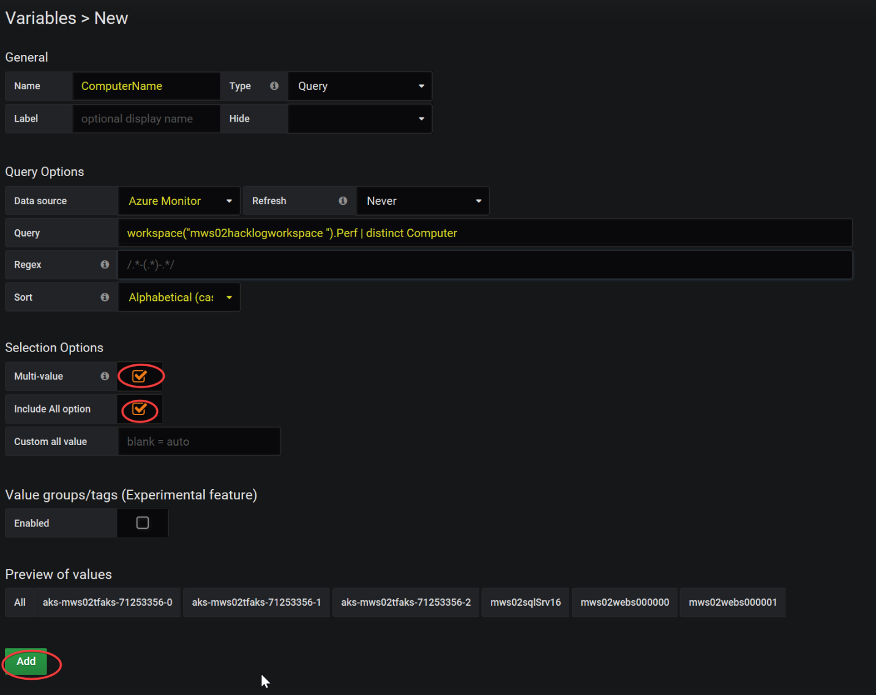

Click Add.

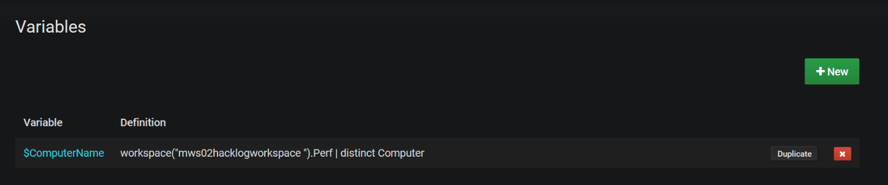

Make sure to Save your dashboard

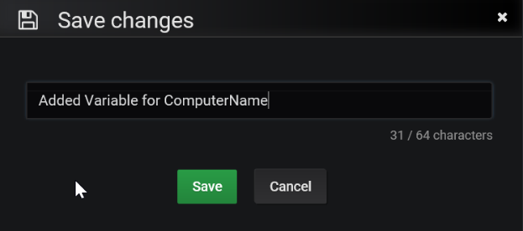

Now go back and edit your Computer CPU chart to update the query to use the new variable.

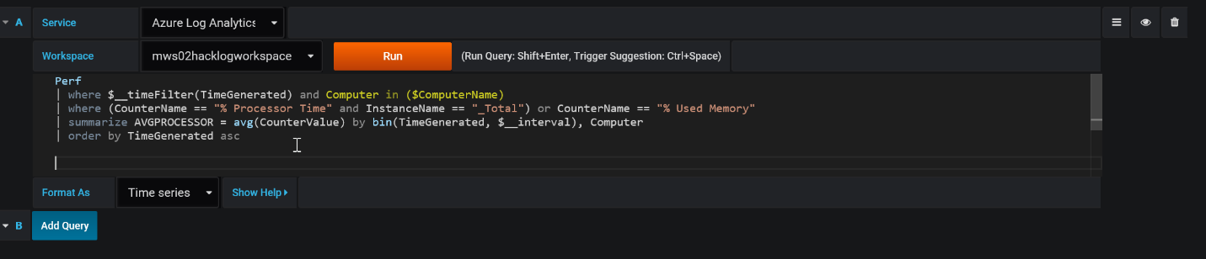

Sample update Computer CPU query to support variable $ComputerName

Perf

| where $__timeFilter(TimeGenerated) and Computer in ($ComputerName)

| where (CounterName == "% Processor Time" and InstanceName == "_Total") or CounterName == "% Used Memory"

| summarize AVGPROCESSOR = avg(CounterValue) by bin(TimeGenerated, $__interval), Computer

| order by TimeGenerated asc

Make sure to Save

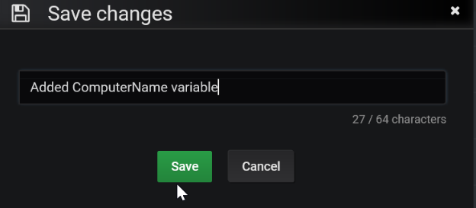

Try it out!

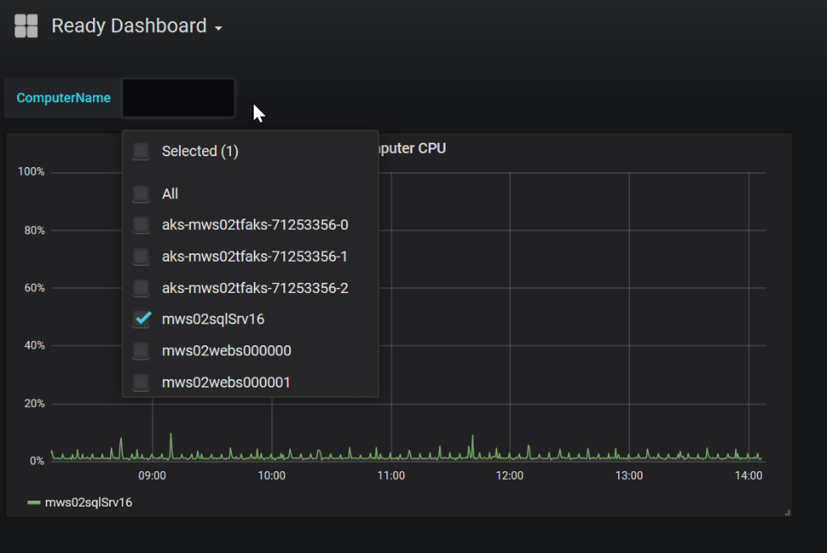

Try creating a variable that accepts percentiles (50, 90 and 95).

* **Annotations**

Another cool Grafana feature is annotations – which marks points in time that you can overlay on top of charts.

Below, you can see the same chart shown above, with an annotation of Heartbeats. Hovering on a specific annotation shows informative text about it.

**Configuration** is very similar to Variables:

Click the dashboard Settings button (on the top right area), select “Annotations”, and then “+New”.

This page shows up, where you can define the data source (aka “Service”) and query to run in order to get the list of values (in this case a list of computer heartbeats).

Note that the output of the query should include a date-time value, a Text field with interesting info (in this case we used the computer name) and possibly tags (here we just used “test”).

Add an Annotation to your chart overlaying Computer Heartbeat

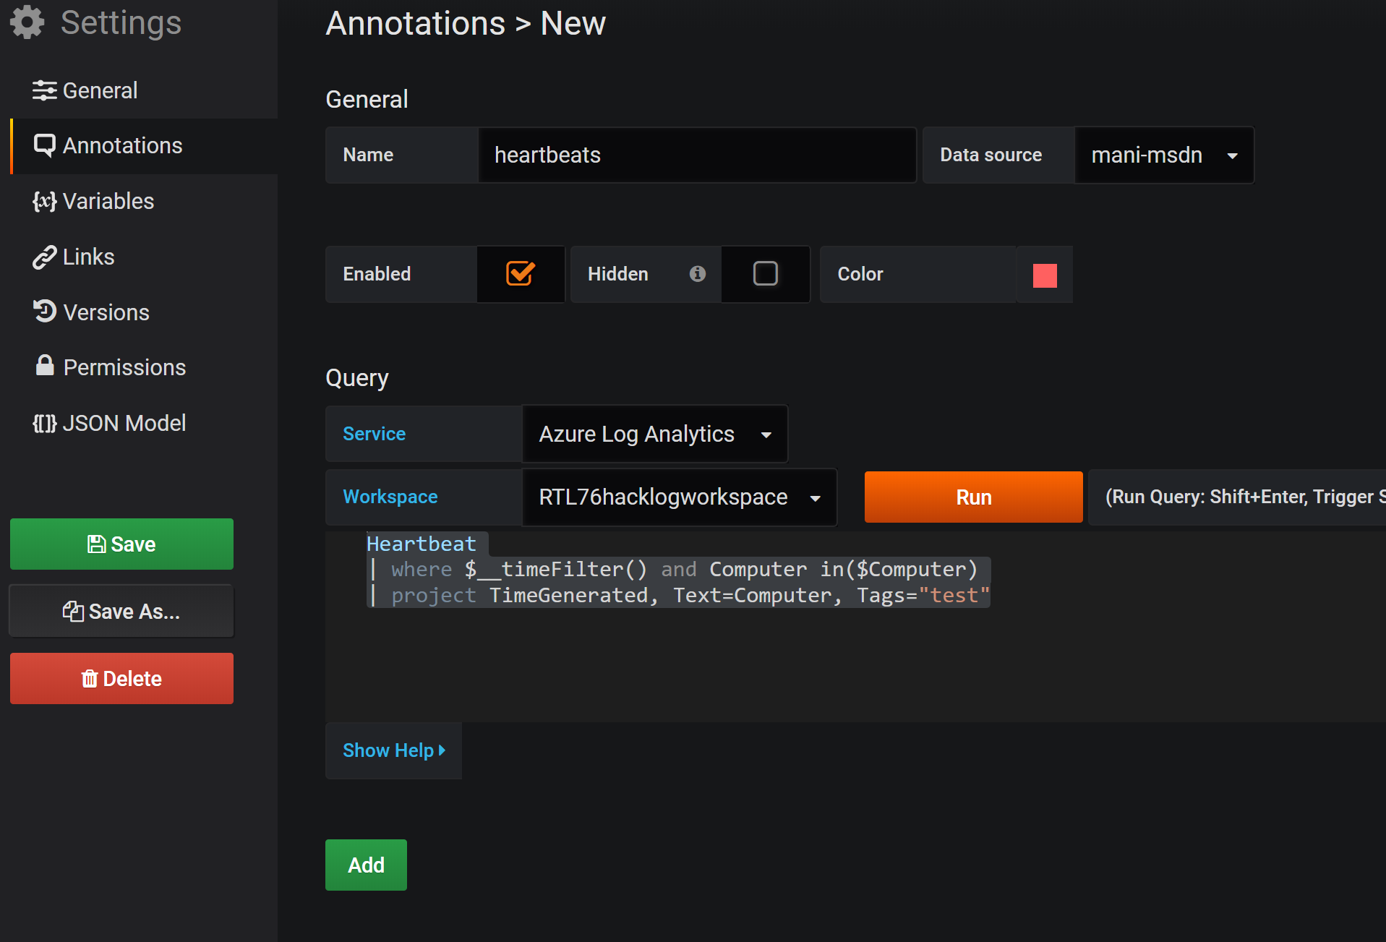

FYI… Annotations provide a way to mark points on the graph with rich events. When you hover over an annotation you can get event description and event tags. The text field can include links to other systems with more detail.

Navigate to settings from your dashboard (the gear in the upper right), click on Annotations, Add Annotation Query

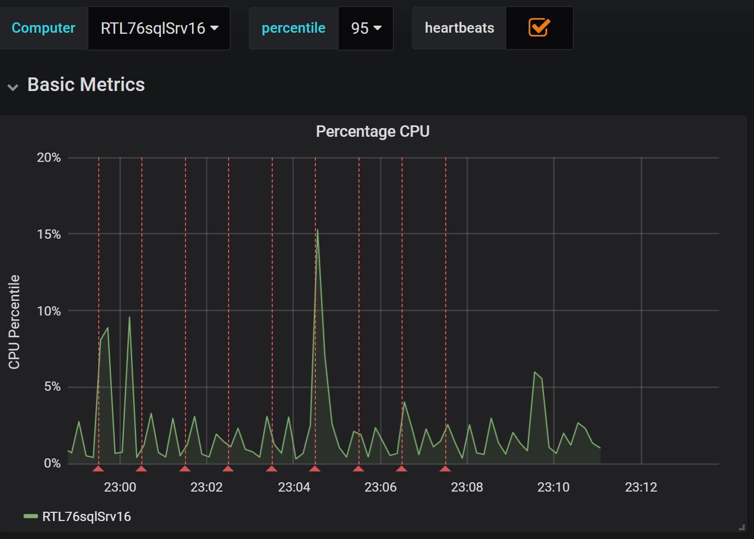

HINT: Use the sample Kusto/Data explorer queries to create more dashboard scenarios.

* First Team to email me a screenshot with your chart wins the challenge. Good luck!

# Challenge 6a: Workbooks

Workbook documentation is available here: <https://docs.microsoft.com/en-us/azure/azure-monitor/app/usage-workbooks>

Navigate to your Application Insights resource in the Portal

Click on Workbooks 🡪 New

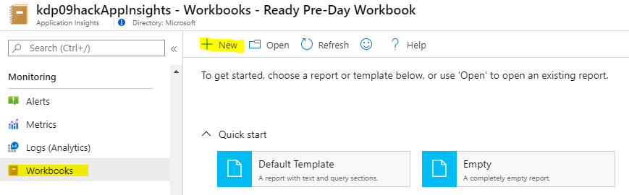

Click Edit in the New Workbook section to describe the upcoming content in the workbook. Text is edited using Markdown syntax.

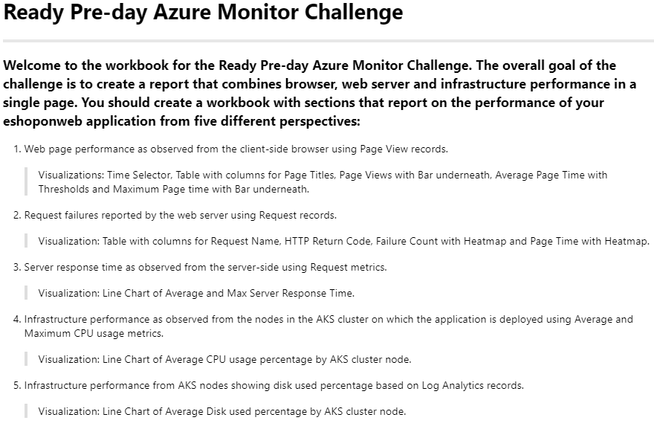

Use **Add text** to describe the upcoming table

Use **Add parameters** to create the time selector

Use **Add query** to retrieve data from pageViews

Use **Column Settings** to change labels of column headers and use Bar and Threshold visualizations.

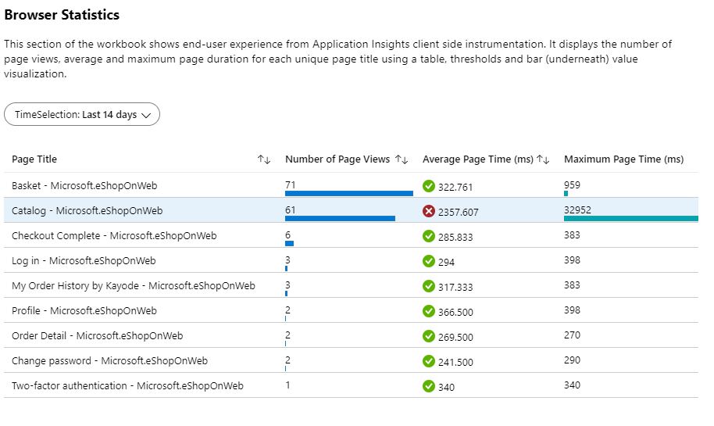

Query used for section Browser Statistics

pageViews

| summarize pageSamples = count(itemCount), pageTimeAvg = avg(duration), pageTimeMax = max(duration) by name

| sort by pageSamples desc

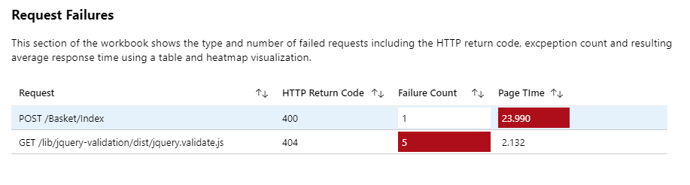

Query used for Request Failures

requests

| where success == false

| summarize total_count=sum(itemCount), pageDurationAvg=avg(duration) by name, resultCode

Use **Add Metric** to create a metric chart

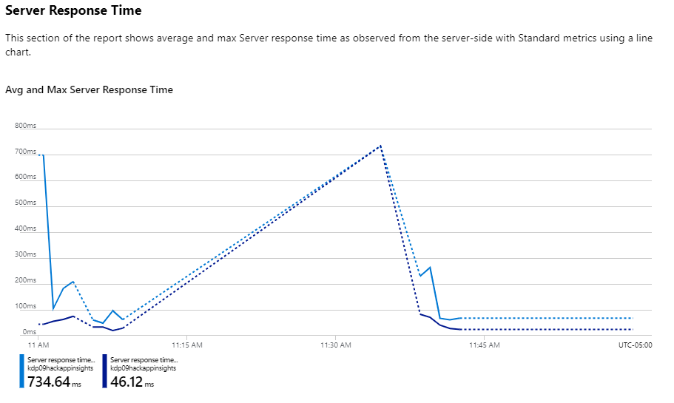

Change your **Resource Type** to Virtual Machine

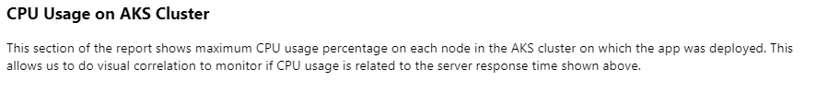

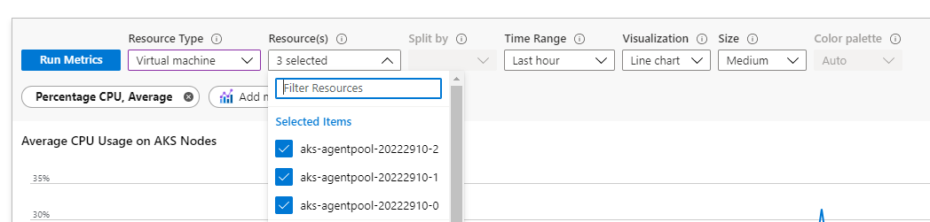

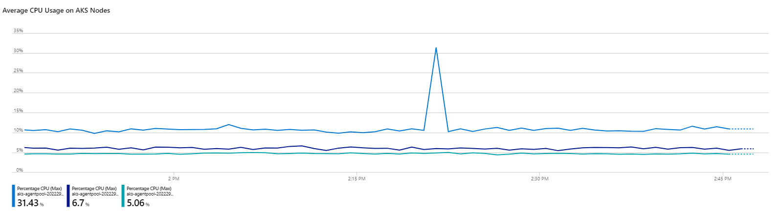

Change the Resource Type to **Log Analytics**

Change your workspace to the LA workspace with your AKS container logs

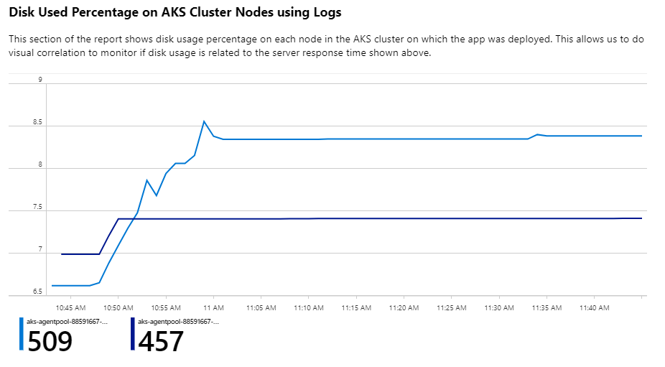

Query used for section Disk Used Percentage

InsightsMetrics

| where Namespace == "container.azm.ms/disk"

| where Name == "used_percent"

| project TimeGenerated, Computer, Val

| summarize avg(Val) by Computer, bin(TimeGenerated, 1m)

| render timechart

Save your workbook.